G1 WP 3
Speed and distance monitoring architecture

Introduction
Speed and monitoring analysis is mainly based on chapter 3.13 and 3.14.
These functions group braking curves calculation and braking intervention (overpass EOA, overspeed, T_NVCONTACT, roll away…).
The analysis is not finished and descriptions have to be added. Only the first step (Emergency brake application scenarios) is ended.

The results of analysis lead to:
- scenario figures,
- list of functions,
- list of external item,
- traceability between requirement and functions.
A html model of these data is also available.

Color code
- blue: track
- red: driver / DMI
- yellow: train
- green: link with location model
- rose: mode and level model
- light green: internal model

Step indicate in which WP3-G1 step the function or item will be modelised.

Scenarios

FT - Speed and distance monitoring
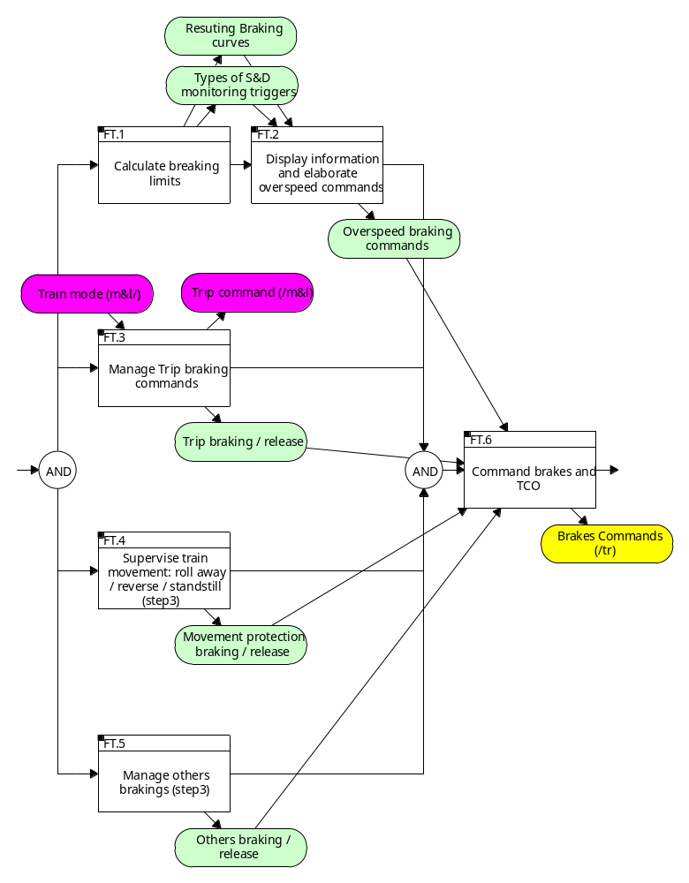
Description
The speed and distance monitoring:
- calculates the braking curves
- supervise the train movements
- command the brakes
- sends display information to the DMI.
This model, as a first step, do not take in account display information.

FT.1 - Calculate breaking limits
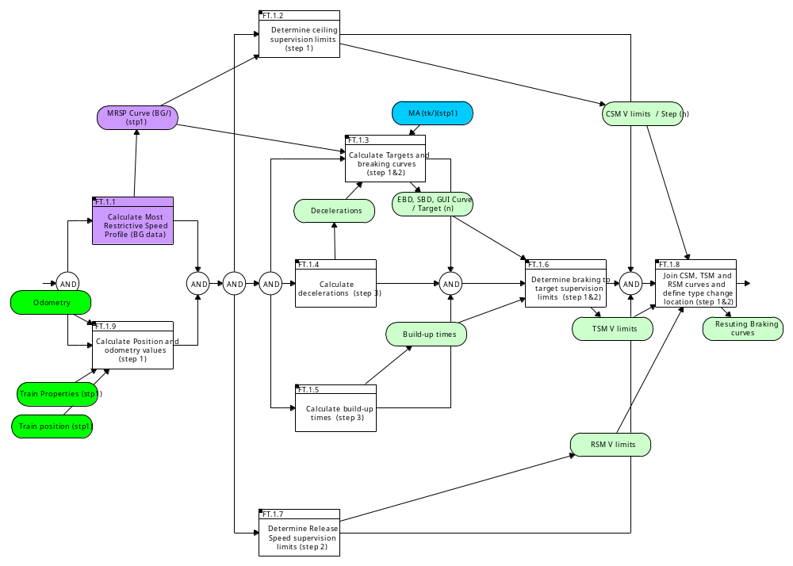
Description
On-board shall always calculate breaking limits:
- ceiling limit, used when the speed is constant and if no target as to be taken in account (P, W, FLOI, EBI,)
- target limit, used if at least one target (change of speed, EOA) as to be taken in account
- release speed, used when the train is near an EOA and needs to approach this EOA.
These on-board limits shall be linked as explained in figures 55 and 56
Breaking limits are related to an absolute point (LRBG for example), not to the front end of the train.

FT.1.1 - Calculate Most Restrictive Speed Profile (BG data)
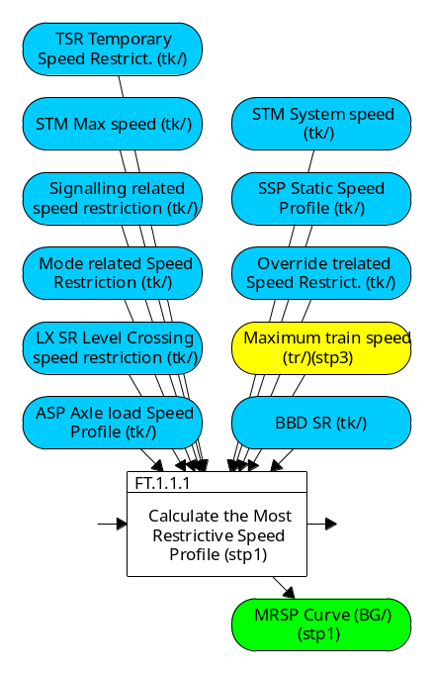
Description
The Most Restrictive Speed Profile (MRSP) is a description of the most restrictive speed restrictions the train shall obey on a given piece of track.
The Most Restrictive Speed Profile shall be computed from all speed restrictions (see 3.13.2.2.13 & 3.13.2.3.2) by selecting the most restrictive parts of each element, some elements being compensated by the train length if requested by trackside (see 3.11.3.1.3 for SSP, 3.11.4.6 for ASP and 3.11.5.3 for TSR).
The Most Restrictive Speed Profile shall be recalculated when any of the elements it is built of is changed.This function is out of W3-G1 perimeter.

FT.1.2 - Determine ceiling supervision limits (step 1)
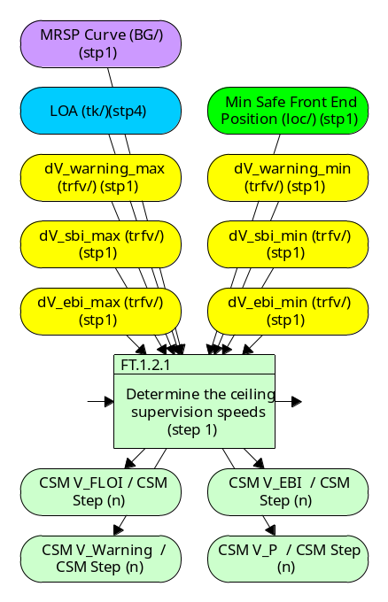
Description
For each MRSP step or LOA, the on-board calculates:
- one EBI limit
- one FLOI limit
- one W limit
- one P limit

FT.1.3 - Calculate Targets and breaking curves (step 1&2)
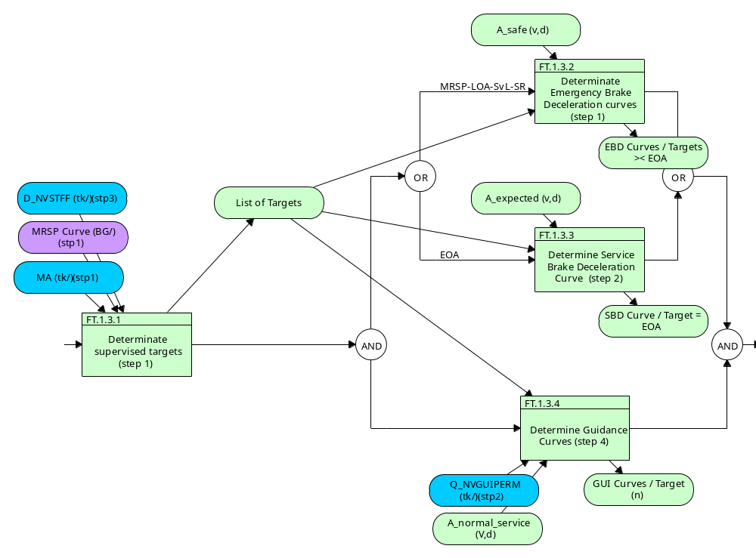
Description
The on-board calculates braking curves EBD or SBD for each target:
- decrease of the MRSP
- Limit of Authority (LOA), if the target speed at the EOA/LOA is not equal to zero
- End of Authority (EOA) and the Supervised Location (SvL), if the target speed at the EOA is equal to zero
- the location deduced from the maximum permitted distance to run in Staff Responsible, with a target speed zero

FT.1.4 - Calculate decelerations (step 3)
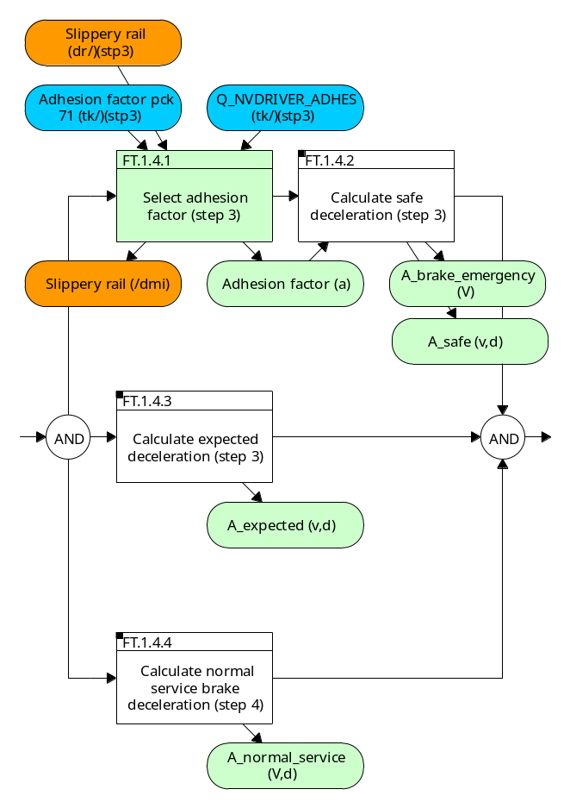
Description
On-board calculates:
- Safe deceleration (safety relevant), used to calculate Emergency Breaking Curve EBD,
- Expected deceleration (not safety relevant), used to calculate Full Service Breaking Curve SBD,
- Normal service brake deceleration (not safety relevant), used to calculate Guidance Curve GUI.

FT.1.4.2 - Calculate safe deceleration (step 3)
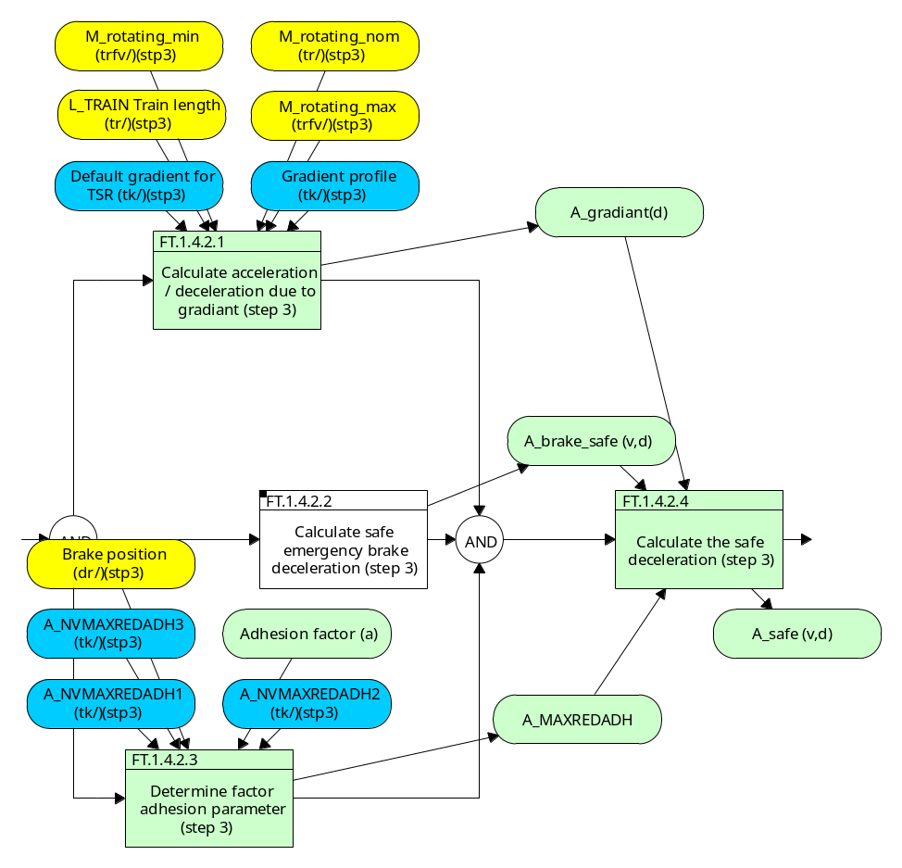
Description
The safe deceleration is used to calculate the emergency braking curve.
It shall take in account:
- the train emergency brake deceleration,
- the gradient,
- the state of the rail (slippery or not).

FT.1.4.2.2 - Calculate safe emergency brake deceleration (step 3)
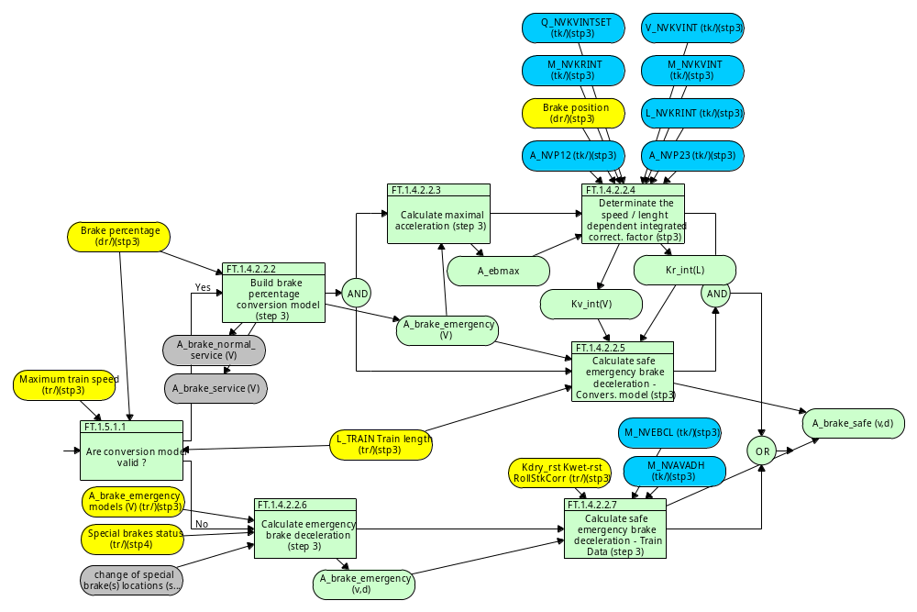
Description
There are two ways to elaborate the safe emergency brake deceleration:
- by calculation: a conversion model is made from the brake percentage and correction factors (given by the track) are added.
- by pre-registered curves. In this case rolling stock correction factors shall be taken in account.

FT.1.4.3 - Calculate expected deceleration (step 3)
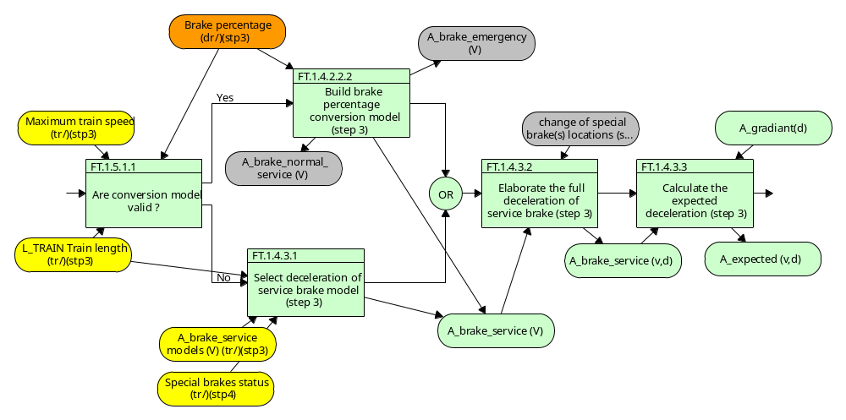
Description
Since the expected deceleration is not safety relevant, no worst case conditions (e.g. correction factors, adhesion conditions) need to be taken into account for its calculation.
The speed dependent deceleration model(s) for the full service brake is acquired as part of Train Data (see 3.13.2.2.3.1) or is derived from the brake percentage using the conversion model (see 3.13.3.3)
A_brake_servicex(V) is equal to the full service brake model, A_brake_service, applicable for the concerned combination of brake.

FT.1.4.4 - Calculate normal service brake deceleration (step 4)
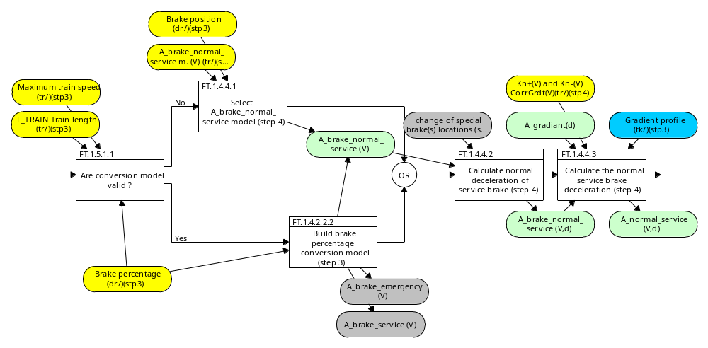
Description
*Since the normal service brake deceleration is not safety relevant, no worst case conditions (e.g. correction factors, adhesion conditions) need to be taken into account for its calculation.
* The speed dependent deceleration model(s) for the service brake is acquired as part of Train Data (see 3.13.2.2.3.1) or is derived from the brake percentage using the conversion model (see 3.13.3.3) ?
A_brake_normal_servicex (V) is equal to the normal service brake model applicable for the concerned combination of brake position and of the value of A_brake_service(V=0) between dx-1 and dx (see 3.13.2.2.3.1.9 and 3.13.2.2.3.1.10).

FT.1.5 - Calculate build-up times (step 3)
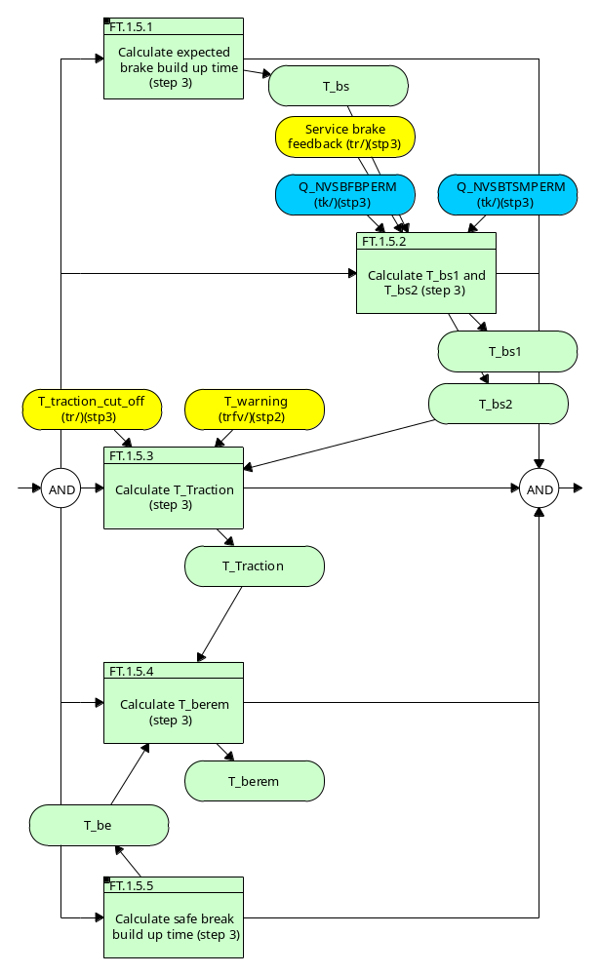
Description
On-board calculates following build-up times:
- T_bs, T_bs1, T_bs2: time between the service brake command and the full application of the service braking, used to calculate SBI1 and SBI2 (not safety relevant)
- T_be: time between the emergency brake command and the full application of the service braking, used to calculate EBI (safety relevant), split in:
T_Traction: time between the brake emergency command and the end of the traction
T_berem : time between the end of the traction and the full application of the emergency braking

FT.1.5.1 - Calculate expected brake build up time (step 3)
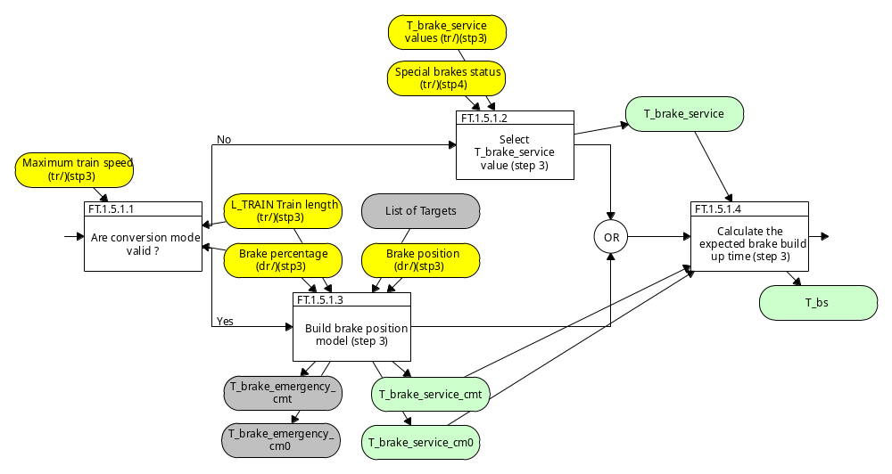
Description
The values of T_brake_service acquired as part of Train Data (see 3.13.2.2.3.2.8) or the value(s) of T_brake_service derived from the conversion model (see 3.13.3.4) using the brake position and train length acquired as Train Data).
Since the expected brake build up time is not safety relevant, no worst case conditions (e.g. correction factors, adhesion conditions) need to be taken into account for its calculation.
The expected brake build up time T_bs shall be equal to the brake build up time of the full service brake:
T_bs = T_brake_service, with T_brake_service corresponding to the combination of special brakes currently in use

FT.1.5.5 - Calculate safe break build up time (step 3)
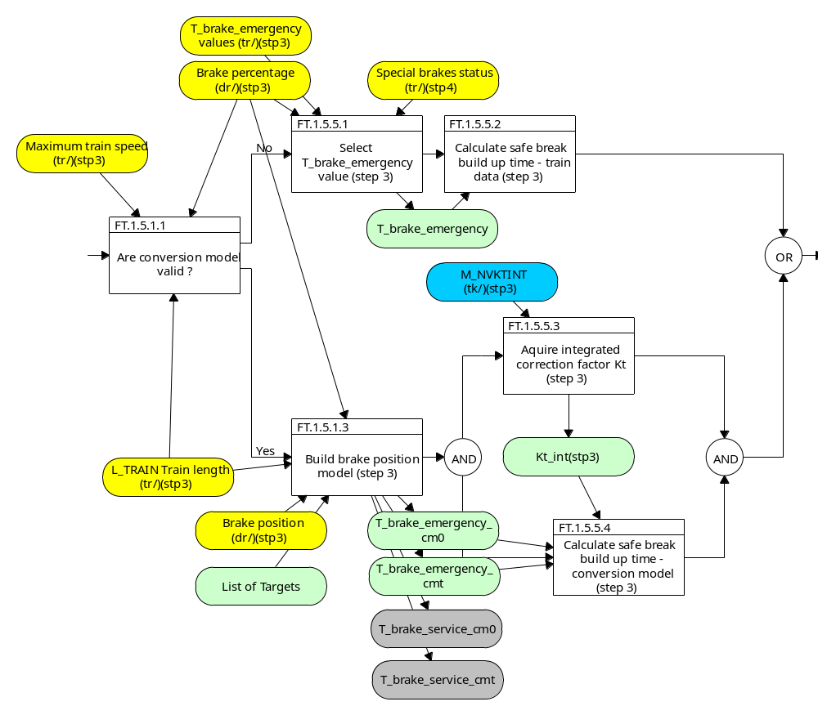
Description
The values of T_brake_emergency acquired as part of Train Data (see 3.13.2.2.3.2.8) or the value(s) of T_brake_emergency derived from the conversion model (see 3.13.3.4) using the brake position and train length acquired as Train Data.

FT.1.6 - Determine braking to target supervision limits (step 1&2)
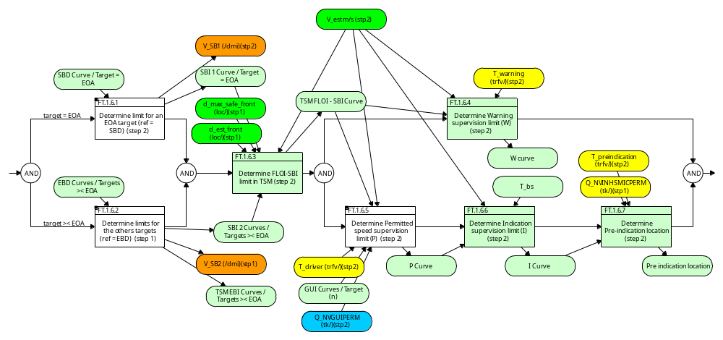
Description
The braking to target supervision limits are derived from the EBD and SBD curves.

The on-board calculates:
* for each EBD curve: an Emergency brake intervention (EBI) and a Service brake intervention 2 (SBI2)(see Figure 45)
* for the SBD curve (if existing): a Service brake intervention 1 (SBI1) (see Figure 46)
Then the on-board calculates the most restrictive SBI curve with SBI1 and SBI2 curves and defines the FLOI.
Then Warning (W), Permitted speed (P) and Indication (I) supervision limits are defined (see figure 45 or 46)

N.B. No specific supervision limit is calculated from the GUI curve: it is only used to adjust the Permitted speed (P) supervision limit, which is obtained either from the EBD or the SBD curve.

FT.1.6.1 - Determine limit for an EOA target (ref = SBD) (step 2)
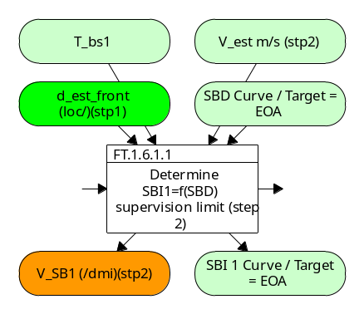
Description

FT.1.6.2 - Determine limits for the others targets (ref = EBD) (step 1)
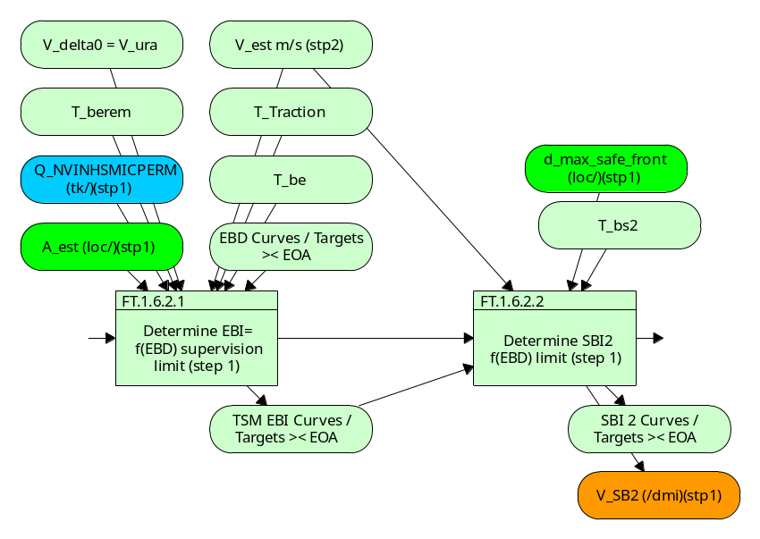
Description
For an EBD based target, the on-board shall calculate the location of:
- the Emergency Brake Intervention which takes in account the delay between the command of the Emergency Brake and its full application (without EBD curve overpassing).
- the Service Brake Intervention (SBI2) which takes in account the delay between the command of the Service Brake and its full application (without EBI curve overpassing).

FT.1.7 - Determine Release Speed supervision limits (step 2)
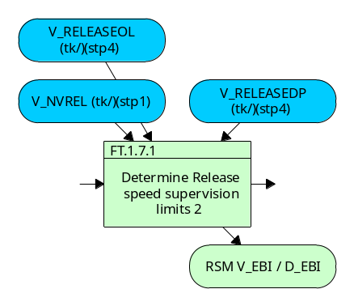
Description
In the vicinity of the EOA, on-boad calculates one release speed used by the train to approch the EOA.

FT.1.8 - Join CSM, TSM and RSM curves and define type change location (step 1&2)
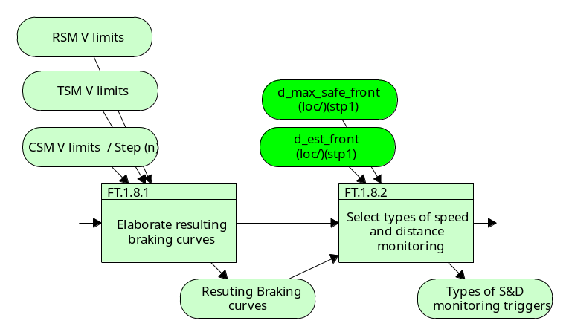
Description

FT.1.9 - Calculate Position and odometry values (step 1)
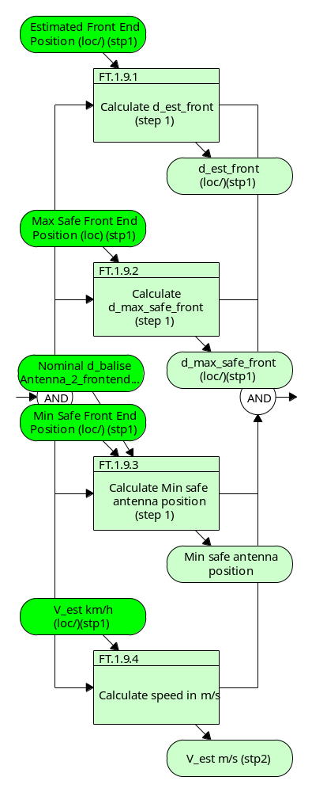
Description

FT.2 - Display information and elaborate overspeed commands
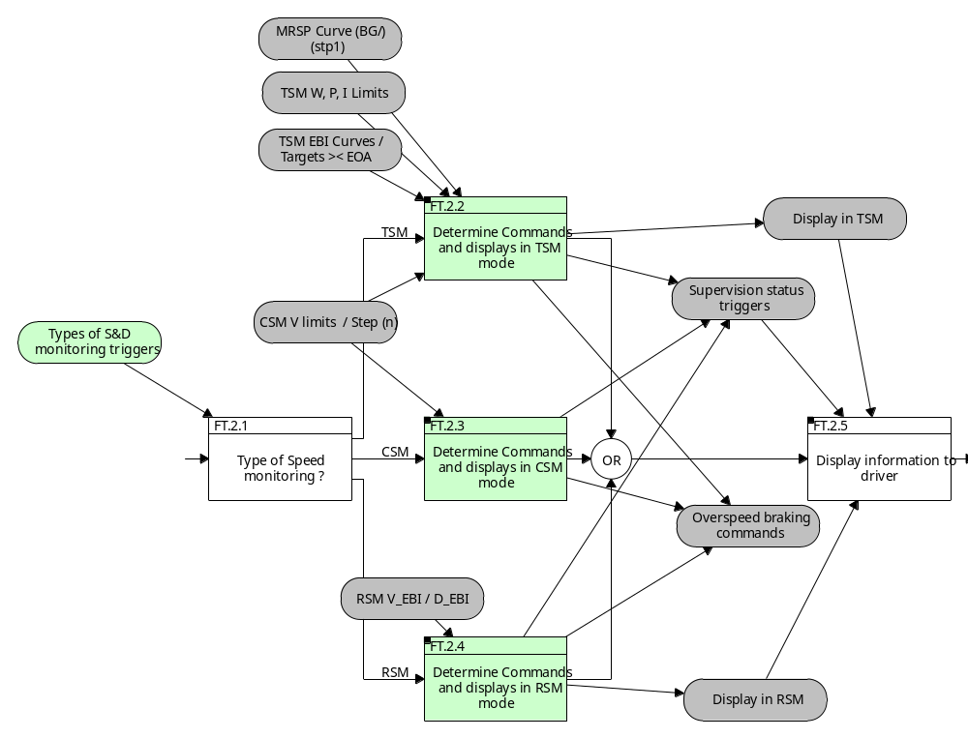
Description

FT.2.2 - Determine Commands and displays in TSM mode
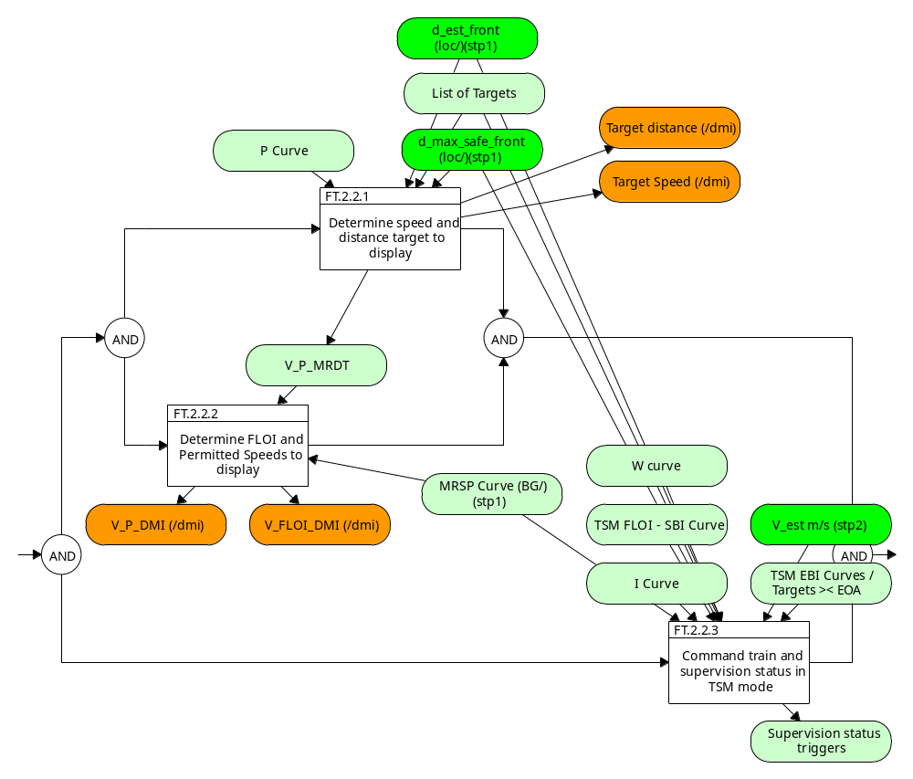
Description
* Target speed monitoring is the speed and distance supervision in the area where the specific information related to a target is displayed to the driver and within which the train brakes to a target.
* In target speed monitoring, both the ceiling supervision limits and the braking to target supervision limits, described in sections 3.13.9.2 and 3.13.9.3, are used to determine the commands to the Train Interface and the information displayed to the driver.

FT.2.3 - Determine Commands and displays in CSM mode
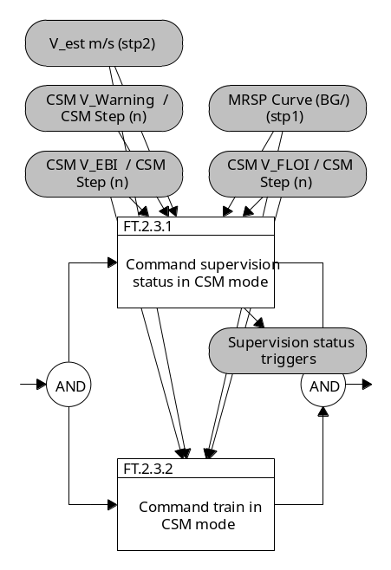
Description
Ceiling speed monitoring is the speed supervision in the area where the train can run with the speed as defined by the MRSP without the need to brake to a target.
The on-board shall compare the estimated speed with the ceiling supervision limits defined in section 3.13.9.2 and shall trigger/revoke commands to the train interface (service brake if implemented or emergency brake) and supervision statuses as described in Table 5 and Table 6.

FT.2.4 - Determine Commands and displays in RSM mode
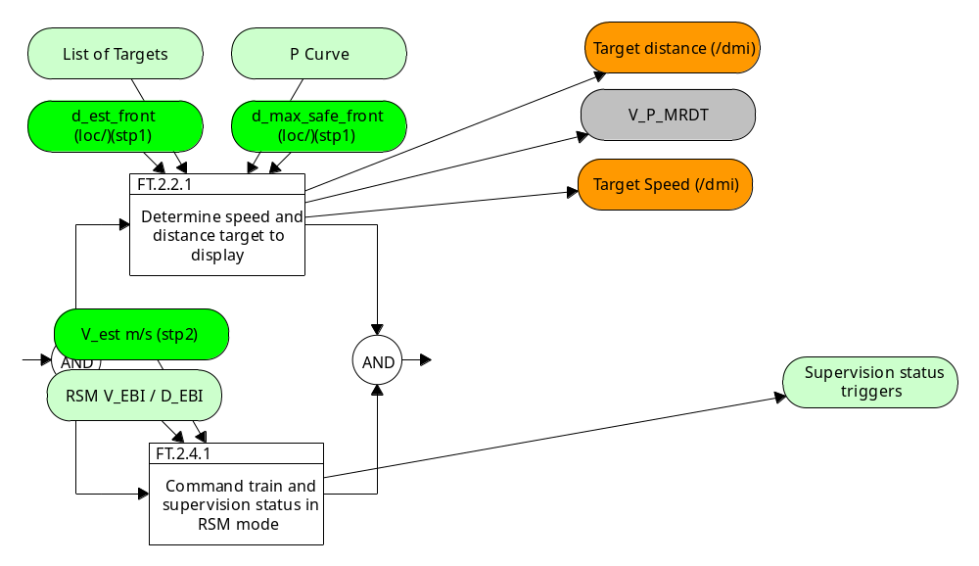
Description
Release speed monitoring is the speed and distance supervision in the area close to the EOA where the train is allowed to run with release speed to approach the EOA.

FT.2.5 - Display information to driver
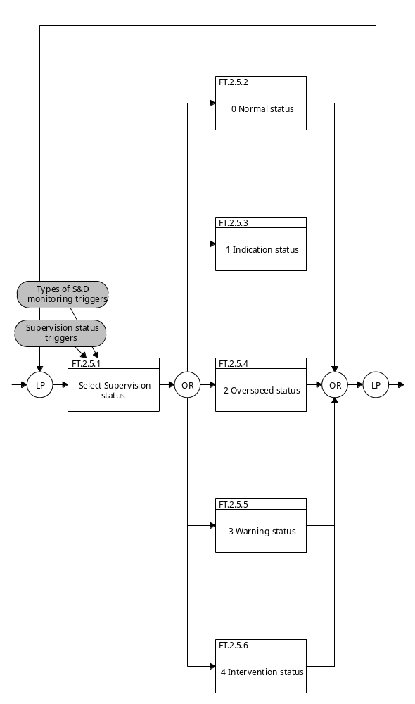
Description

FT.3 - Manage Trip braking commands
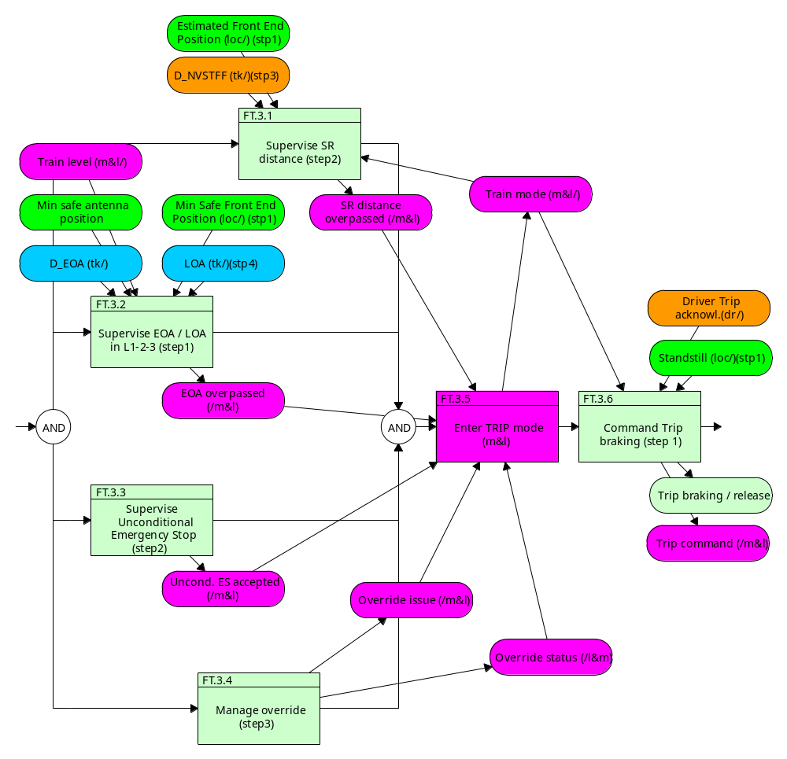
Description

FT.4 - Supervise train movement: roll away / reverse / standstill (step3)
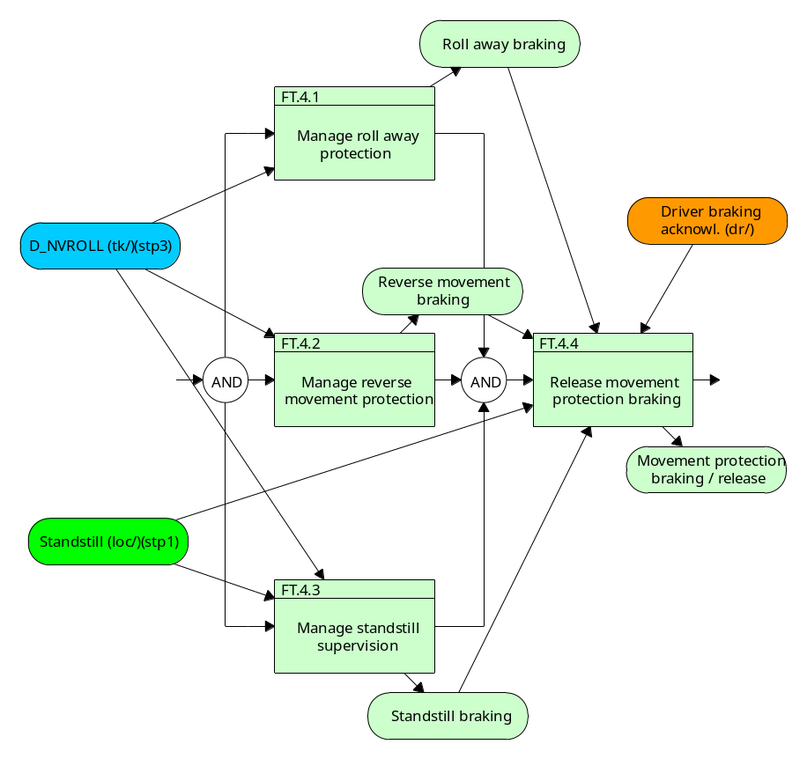
Description

FT.5 - Manage others brakings (step3)
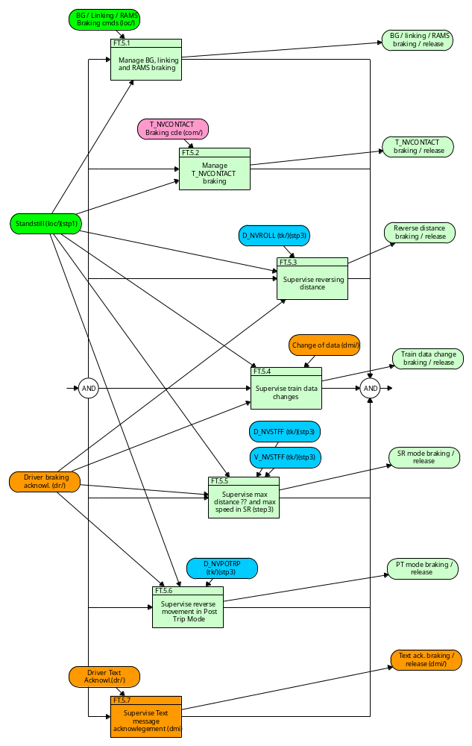
Description

FT.6 - Command brakes and TCO
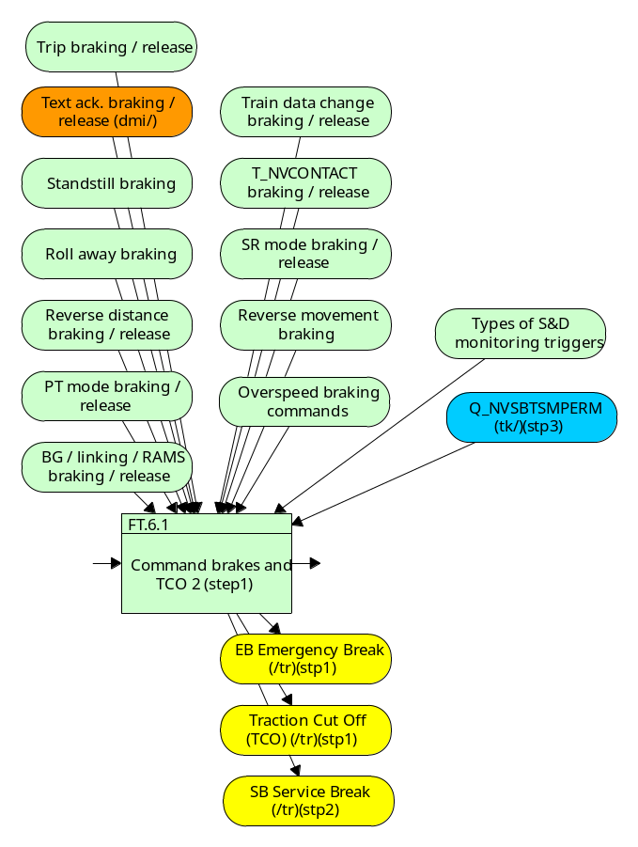
Description

List of the functions
Number and Name | description
FT.1 Calculate breaking limits | On-board shall always calculate breaking limits:  - ceiling limit, used when the speed is constant and if no target as to be taken in account (P, W, FLOI, EBI,)  - target limit, used if at least one target (change of speed, EOA) as to be taken in account  - release speed, used when the train is near an EOA and needs to approach this EOA.  These on-board limits shall be linked as explained in figures 55 and 56  Breaking limits are related to an absolute point (LRBG for example), not to the front end of the train.
FT.1.1 Calculate Most Restrictive Speed Profile (BG data) | The Most Restrictive Speed Profile (MRSP) is a description of the most restrictive speed restrictions the train shall obey on a given piece of track.  The Most Restrictive Speed Profile shall be computed from all speed restrictions (see 3.13.2.2.13 & 3.13.2.3.2) by selecting the most restrictive parts of each element, some elements being compensated by the train length if requested by trackside (see 3.11.3.1.3 for SSP, 3.11.4.6 for ASP and 3.11.5.3 for TSR).  The Most Restrictive Speed Profile shall be recalculated when any of the elements it is built of is changed.This function is out of W3-G1 perimeter.
FT.1.1.1 Calculate the Most Restrictive Speed Profile (stp1) | The Most Restrictive Speed Profile (MRSP) is a description of the most restrictive speed restrictions the train shall obey on a given piece of track.  The Most Restrictive Speed Profile shall be computed from all speed restrictions  - maximum train speed (3.13.2.2.13)  - trackside speed restrictions (3.13.2.3.2)  a) Static Speed Profile (SSP)  b) Axle load Speed Profile (ASP)  c) Temporary Speed Restrictions (TSR)  d) Maximum Train Speed  e) Signalling related speed restriction (only level 1)  f) Mode related Speed Restriction.  g) STM Max speed (for details refer to Subset-035)  h) STM System speed (for details refer to Subset-035)  i) Level Crossing speed restriction (LX SR)  j) Override function related Speed Restriction  k) Speed restriction to ensure a given permitted braking distance (PBD SR) (see 3.11.11)  by selecting the most restrictive parts of each element, some elements being compensated by the train length if requested by trackside (see 3.11.3.1.3 for SSP, 3.11.4.6 for ASP and 3.11.5.3 for TSR).  The Most Restrictive Speed Profile shall be recalculated when any of the elements it is built of is changed.
FT.1.2 Determine ceiling supervision limits (step 1) | For each MRSP step or LOA, the on-board calculates:  - one EBI limit  - one FLOI limit  - one W limit  - one P limit
FT.1.2.1 Determine the ceiling supervision speeds (step 1) | See figure 43  * The ceiling supervision limits are derived from the MRSP elements, where the speed is constant (refer to 3.13.7) or from the LOA.  * From an MRSP element or from the LOA, the Permitted speed, Warning, Service brake intervention and Emergency brake intervention supervision limits are defined (see Figure 43).  - Permitted Speed = V_LOA or V_MRSP  - For dv_ebi (margin between Permitted speed and Emergency brake intervention), the following formula shall be applied:  When V_MRSP > V_ebi_min:  dV_ebi = min (dV_ebi_min + C_ebi . (V_MRSP - V_ebi_min), dV_ebi_max)  with C_ebi = (dV_ebi_max - dV_ebi_min) / (V_ebi_max - V_ebi_min)  When V_MRSP < V_ebi_min:  dV_ebi = dV_ebi_min  (see figure 44)  V_ebi_min, dV_ebi_max, V_ebi_min and V_ebi_max are defined as fixed values (See Appendix A3.1)  - For dV_sbi (margin between Permitted speed and Service brake intervention) , the same formula as for dV_ebi shall apply, dV_sbi_min, dV_sbi_max, V_sbi_min and V_sbi_max being also defined as fixed values (See Appendix A3.1)  - For dV_warning (margin between Permitted speed and Warning), the same formula as for dV_ebi shall apply, dV_warning_min, dV_warning_max, V_warning_min and V_warning_max being also defined as fixed values (See Appendix A3.1)  * For LOA, the same formulas shall apply, by substituting V_MRSP with V_LOA.  * The SBI supervision limit is also referred as the FLOI (First Line Of Intervention) supervision limit.  * The locations corresponding to a speed increase of the MRSP shall be supervised by the on-board equipment taking into account the min safe front end of the train.  CSM V_EBI = V_MRSP (or V_LOA) + dV_ebi for each CSM step  CSM V_FLOI = V_MRSP (or V_LOA) + dV_sbi for each CSM step  CSM V_Warning = V_MRSP (or V_LOA) + dW_Warning for each CSM step  CSM V_P = V_MRSP (or V_LOA) for each CSM step  CSM Step : location where the V_MRSP is applying = [d_target (beginning), d_target (end)]
FT.1.3 Calculate Targets and breaking curves (step 1&2) | The on-board calculates braking curves EBD or SBD for each target:  - decrease of the MRSP  - Limit of Authority (LOA), if the target speed at the EOA/LOA is not equal to zero  - End of Authority (EOA) and the Supervised Location (SvL), if the target speed at the EOA is equal to zero  - the location deduced from the maximum permitted distance to run in Staff Responsible, with a target speed zero
FT.1.3.1 Determinate supervised targets (step 1) | The on-board shall continuously supervise a list of targets, which may include the following types of target:  a) the locations corresponding to a speed decrease of the MRSP (if any), which are in advance of the max safe front end of the train  b) the Limit of Authority (LOA), if the target speed at the EOA/LOA is not equal to zero  c) the End of Authority (EOA) and the Supervised Location (SvL), if the target speed at the EOA is equal to zero  d) the location deduced from the maximum permitted distance to run in Staff Responsible, with a target speed zero  Note: depending on the information received from trackside and the position of the train, the list of supervised targets may be empty.  * The list of supervised targets shall be re-evaluated when any of the elements it is built of is changed (e.g. new MA and/or track description accepted on-board, EOA and/or SvL temporarily supervised at the start location of a mode profile, update of stored information in specific situations (see sections A.3.4 and 4.10)).  * A target corresponding to a speed decrease of the MRSP shall be removed from the list of supervised targets when the max safe front end of the train has passed the target location.
FT.1.3.2 Determinate Emergency Brake Deceleration curves (step 1) | * If a target belongs to the MRSP or is an LOA, the on-board shall calculate an EBD curve based on the safe deceleration A_safe(V,d), that crosses the ceiling speed EBI supervision limit (see 3.13.9.2) at the target location, and that extends up to the location where the target speed is reached (EBD foot).  * If a target is an SvL, the on-board shall calculate an Emergency Brake Deceleration (EBD) curve based on the safe deceleration A_safe(V,d) and that reaches zero speed at the SvL.  * If a target is the location at the end of the maximum permitted distance to run in Staff Responsible, the on-board shall calculate an Emergency Brake Deceleration (EBD) curve based on the safe deceleration A_safe(V,d) and that reaches zero speed at this staff responsible end location.  See figures 40 and 41.
FT.1.3.3 Determine Service Brake Deceleration Curve (step 2) | If a target is an EOA, the on-board shall calculate an Service Brake Deceleration (SBD) curve based on the expected deceleration A_expected (V,d) and that reaches zero speed at this EOA location.  See figure 42
FT.1.3.4 Determine Guidance Curves (step 4) | * The purpose of the guidance curve (GUI) is to provide a comfortable way of braking for the driver, to avoid excessive wear of the brakes and to save traction energy.  * If the National Value does not inhibit them, the on-board shall calculate a guidance curve (GUI) for each supervised target, based on the normal service brake deceleration A_normal_service(V,d). The foot of a GUI curve (i.e. the location where the GUI speed is equal to the target speed) shall be:  a) the target location, in case of EOA/SvL  b) the location defined in 3.13.9.3.5.9, for others targets
FT.1.4 Calculate decelerations (step 3) | On-board calculates:  - Safe deceleration (safety relevant), used to calculate Emergency Breaking Curve EBD,  - Expected deceleration (not safety relevant), used to calculate Full Service Breaking Curve SBD,  - Normal service brake deceleration (not safety relevant), used to calculate Guidance Curve GUI.
FT.1.4.1 Select adhesion factor (step 3) | The selection of the adhesion value from trackside or by driver entry shall be limited to the options slippery rail/ non slippery rail.  The default value for the adhesion factor shall be the highest value (i.e. not slippery rail).  The adhesion factor may be changed while the train is running.  It shall be possible to update the adhesion factor from trackside and - if permitted by a National value - by the driver. If, following a change of National Values, the update of the adhesion factor is no more permitted to the driver, the adhesion factor previously modified by the driver to slippery rail shall immediately be reset to non slippery rail. Any trackside adhesion profile is not affected.  The driver shall be informed whether the value of the adhesion factor is “slippery rail”.  The speed and distance monitoring shall use, as resulting reduced adhesion conditions, the most restrictive value of the adhesion conditions selected by the driver and the adhesion conditions calculated from the trackside profile.  From the adhesion profile given by trackside, the on-board shall consider locations with reduced adhesion conditions over a distance going from the start location of the profile to the location derived by adding the train length to the end location of the profile.  When slippery rail is selected by the driver, all locations shall be considered with reduced adhesion conditions.
FT.1.4.2 Calculate safe deceleration (step 3) | The safe deceleration is used to calculate the emergency braking curve.  It shall take in account:  - the train emergency brake deceleration,  - the gradient,  - the state of the rail (slippery or not).
FT.1.4.2.1 Calculate acceleration / deceleration due to gradiant (step 3) | The elements of the gradient profile given from trackside shall be compensated:  a) in location according to the train length (the lowest gradiant under the train)  b) in value according to the rotating mass in order to derive the corresponding acceleration/deceleration.  The default gradient for TSR shall be compensated in value according to the rotating mass.  For all locations not covered by the gradient profile, the on-board shall consider the gradient value as:  a) the default gradient for TSR, if available and if the concerned target is due to a TSR,  b) zero, for other cases.  The following formulas shall be used for the rotating mass:  a) If M_rotating_nom is unknown:  - Uphill: A_gradient = g * grad / (1000+10*M_rotating_max)  - Downhill: A_gradient = g * grad / (1000+10*M_rotating_min)  b) If M_rotating_nom is known:  - Uphill: A_gradient = g * grad / (1000+10*M_rotating_nom)  - Downhill: A_gradient = g * grad / (1000+10*M_rotating_nom)  Legend:  A_gradient = acceleration/deceleration due to gradient (the lowest gradiant under the train)  g = 9.81 m/s2 - acceleration of gravity in m/s2  grad = gradient values in ‰ (positive = uphill)  M_rotating_nom = nominal rotating mass (part of train data) as a percentage of the total train weight  M_rotating_max = maximum possible rotating mass (see A3.1) as a percentage of the total train weight  M_rotating_min = minimum possible rotating mass (see A3.1) as a percentage of the total train weight
FT.1.4.2.2 Calculate safe emergency brake deceleration (step 3) | There are two ways to elaborate the safe emergency brake deceleration:  - by calculation: a conversion model is made from the brake percentage and correction factors (given by the track) are added.  - by pre-registered curves. In this case rolling stock correction factors shall be taken in account.
FT.1.4.2.2.2 Build brake percentage conversion model (step 3) | If the brake percentage is captured as Train Data and the conversion model is applicable (see 3.13.3.2), they are used to derive A_brake_emergency(V), A_brake_service(V), T_brake_emergency and T_brake_service.  If the brake percentage is captured as Train Data and the conversion model is used (see 3.13.3.2 for its validity limits), no rolling stock correction factor shall apply.  The basic deceleration A_basic(V) shall be given as a step function of the speed using the algorithm defined in Appendix A3.7.  A.3.7  * The brake percentage (lambda ) shall be converted into two different input parameters:  lambda_o = lambda for calculation of emergency brake deceleration (A_brake_emergency(V))  lambda_o = MIN (lambda , 135) for calculation of service brake deceleration (A_brake_service(V))  where lambda is the brake percentage defined as part of Train Data.  * The calculation of the basic deceleration (A_basic(V)) shall use a common algorithm that will be used twice, once for the service brake and once for the emergency brake.  * The speed limit for the first step shall be calculated as V_lim = x * lambda_oy.  V_lim is the speed limit for the first step in km/h  x = 16.85  y = 0.428  * The first step of the basic deceleration shall be calculated as AD_0 = A * lambda_o + B  AD_0 is the basic deceleration in m/s2 for 0 = speed = V_lim.  A = 0.0075  B = 0.076  * The following steps of the basic deceleration shall be calculated by means of a set of polynomials of the third order with the following format:  AD_n = a3_n * lambda_o3 + a2_n * lambda_o2 + a1_n * lambda_o + a0_n  and with the following values for n (all speed limits in km/h):  n = 1 valid for V_lim < speed = 100 if V_lim = 100  to be ignored if V_lim > 100  n = 2 valid for V_lim < speed = 120 if 100 < V_lim = 120  valid for 100 < speed = 120 if V_lim = 100  to be ignored if V_lim > 120  n = 3 valid for V_lim < speed = 150 if 120 < V_lim = 150  valid for 120 < speed = 150 if V_lim = 120  to be ignored if V_lim > 150  n = 4 valid for V_lim < speed = 180 if 150 < V_lim = 180  valid for 150 < speed = 180 if V_lim = 150  to be ignored if V_lim > 180  n = 5 valid for V_lim < speed if V_lim > 180  valid for 180 < speed if V_lim = 180  * The coefficients for the polynomials shall be defined as follows:  am_n:  n=1 : m=3 => a=-6.30E-07  n=1 : m=2 => a=6.10E-05  n=1 : m=1 => a=4.72E-03  n=1 : m=0 => a=0.0663  n=2 : m=3 => a=2.73E-07  n=2 : m=2 => a=-4.54E-06  n=2 : m=1 => a=5.14E-03  n=2 : m=0 => a=0.1300  n=3 : m=3 => a=5.58E-08  n=3 : m=2 => a=-6.76E-06  n=3 : m=1 => a=5.81E-03  n=3 : m=0 => a=0.0479  n=4 : m=3 => a=3.00E-08  n=4 : m=2 => a=-3.85E-06  n=4 : m=1 => a=5.52E-03  n=4 : m=0 => a=0.0480  n=5 : m=3 => a=3.23E-09  n=5 : m=2 => a=1.66E-06  n=5 : m=1 => a=5.06E-03  n=5 : m=0 => a=0.0559
FT.1.4.2.2.3 Calculate maximal acceleration (step 3) | The maximum EB deceleration A_ebmax shall be the maximum of A_brake_emergency between 0 km/h and the maximum speed of the train.
FT.1.4.2.2.4 Determinate the speed / lenght dependent integrated correct. factor (stp3) | Kv_int(V) shall be the integrated correction factor applicable for the train, selected according to the brake position. If the brake position is “Passenger train in P”, the set of Kv_int shall be calculated as a function of the maximum emergency brake deceleration (A_ebmax) in the following way (see also figure 10):  Kv_int_x = Kv_int_x_a when A_ebmax = A_P12.  Kv_int_x = Kv_int_x_b when A_ebmax = A_P23.  Kv_int_x = Kv_int_x_a + (A_ebmax - A_P12)/(A_P23 - A_P12) * (Kv_int_x_b - Kv_int_x_a) when A_P12 < A_ebmax < A_P23.”  Kr_int(l)  The train length dependent correction factor, Kr_int(l), shall be given as a step function.  It shall be possible to define up to five steps for Kr_int(l). Note: An example with 4 steps is given in Figure 34. Kr_int is calculated as follows:  - Kr_int = Kr_int_0 when 0 = train length = L1  - Kr_int = Kr_int_1 when L1 < train length = L2  - Kr_int = Kr_int_2 when L2 < train length = L3  - Kr_int = Kr_int_3 when L3 < train length  The last step of the Kv_int(V) and Kr_int(l) shall by definition be considered as open ended, i.e. it has no upper speed and train length limit, respectively.
FT.1.4.2.2.5 Calculate safe emergency brake deceleration - Convers. model (stp3) | A_brake_safe(V,d) shall be the safe emergency brake deceleration. A_brake_safe(V,d) shall be equal to:  If the conversion model is used:  A_brake_safe(V) = Kv_int(V) * Kr_int(L_TRAIN) * A_brake_emergency(V)
FT.1.4.2.2.6 Calculate emergency brake deceleration (step 3) | * Special brakes: see tables 3 / 4 p.90  * As long as it uses a track condition profile given by trackside, the on-board shall consider locations without special brake contribution over a distance going from the start location of the profile to the foot of the deceleration curve (EBD, SBD or GUI, see sections 3.13.8.3, 3.13.8.4 and 3.13.8.5).  * If the status of a special brake is “not active”, all locations shall be considered without the contribution of this special brake. Note: in such case, a track condition profile implying the inhibition of this special brake will have no effect.  * A_brake_emergency(V,d) shall be the emergency brake deceleration as a function of the speed, of the locations with change of special brake(s) contribution encountered between the train front and the foot of the EBD curve. A_brake_emergency(V,d) shall be equal to:  A_brake_emergency1(V) when destfront = d = d1  A_brake_emergency2(V) when d1 < d = d2  A_brake_emergency3(V) when d2 < d = d3  Where  d1, d2, d3,... are the locations with change of special brake(s) contribution  A_brake_emergencyx(V) is equal to the emergency brake model, A_brake_emergency, applicable for the concerned combination of brake.
FT.1.4.2.2.7 Calculate safe emergency brake deceleration - Train Data (step 3) | * If the braking models are captured as Train Data, rolling stock correction factors shall be defined.  A_brake_safe(V,d) shall be the safe emergency brake deceleration. A_brake_safe(V,d) shall be equal to:  If the speed dependent deceleration model(s) for the emergency brake are acquired as part of Train Data:  A_brake_safe(V,d) = Kdry_rst(V, M_NVEBCL) * (Kwet_rst(V) + M_NVAVADH *(1- Kwet_rst(V))) * A_brake_emergency(V,d)
FT.1.4.2.3 Determine factor adhesion parameter (step 3) | A_MAXREDADH is the deceleration value, out of the three related National Values, applicable for this train according to:  a) its brake position  b) whether adhesion factor is slippery or not  (special/additional brakes independent from wheel/rail adhesion are active and it is allowed to take into account their contribution to the emergency braking effort)
FT.1.4.2.4 Calculate the safe deceleration (step 3) | A_safe(V,d) shall be equal to:  For locations with normal adhesion conditions:  A_safe(V,d) = A_brake_safe(V,d) + A_gradient(d)  For locations with reduced adhesion conditions:  A_safe(V,d) = MIN(A_brake_safe(V,d) , A_MAXREDADH) + A_gradient(d)
FT.1.4.3 Calculate expected deceleration (step 3) | Since the expected deceleration is not safety relevant, no worst case conditions (e.g. correction factors, adhesion conditions) need to be taken into account for its calculation.  The speed dependent deceleration model(s) for the full service brake is acquired as part of Train Data (see 3.13.2.2.3.1) or is derived from the brake percentage using the conversion model (see 3.13.3.3)  A_brake_servicex(V) is equal to the full service brake model, A_brake_service, applicable for the concerned combination of brake.
FT.1.4.3.1 Select deceleration of service brake model (step 3) | Special brakes: see tables 3 / 4 p.90  * As long as it uses a track condition profile given by trackside, the on-board shall consider locations without special brake contribution over a distance going from the start location of the profile to the foot of the deceleration curve (EBD, SBD or GUI, see sections 3.13.8.3, 3.13.8.4 and 3.13.8.5).  * If the status of a special brake is “not active”, all locations shall be considered without the contribution of this special brake. Note: in such case, a track condition profile implying the inhibition of this special brake will have no effect.
FT.1.4.3.2 Elaborate the full deceleration of service brake (step 3) | * A_brake_service(V,d) shall be equal to:  A_brake_service1(V) when destfront = d = d1  A_brake_service2(V) when d1 < d = d2  A_brake_service3(V) when d2 < d = d3  ....  Where  d1, d2, d3,... are the locations with change of special brake(s) contribution
FT.1.4.3.3 Calculate the expected deceleration (step 3) | A_expected(V,d) = A_brake_service(V,d) +A_gradient(d)
FT.1.4.4 Calculate normal service brake deceleration (step 4) | *Since the normal service brake deceleration is not safety relevant, no worst case conditions (e.g. correction factors, adhesion conditions) need to be taken into account for its calculation.  * The speed dependent deceleration model(s) for the service brake is acquired as part of Train Data (see 3.13.2.2.3.1) or is derived from the brake percentage using the conversion model (see 3.13.3.3) ?  A_brake_normal_servicex (V) is equal to the normal service brake model applicable for the concerned combination of brake position and of the value of A_brake_service(V=0) between dx-1 and dx (see 3.13.2.2.3.1.9 and 3.13.2.2.3.1.10).
FT.1.4.4.1 Select A_brake_normal_service model (step 4)
FT.1.4.4.2 Calculate normal deceleration of service brake (step 4) | A_brake_normal_service(V,d) shall be equal to:  A_brake_normal_service1(V) when destfront = d = d1  A_brake_normal_service2(V) when d1 < d = d2  A_brake_normal_service3(V) when d2 < d = d3  ....  Where  d1, d2, d3,... are the locations with change of special brake(s) contribution
FT.1.4.4.3 Calculate the normal service brake deceleration (step 4) | The normal service brake deceleration shall be equal to:  For positive gradient values (uphill):  A_normal_service(V,d) = A_brake_normal_service(V,d) + A_gradient(d) – Kn+(V)*grad  For negative gradient values (downhill):  A_normal_service(V,d) = A_brake_normal_service(V,d) + A_gradient(d) – Kn-(V)*grad  Where  grad = gradient values in ‰ (positive = uphill)
FT.1.5 Calculate build-up times (step 3) | On-board calculates following build-up times:  - T_bs, T_bs1, T_bs2: time between the service brake command and the full application of the service braking, used to calculate SBI1 and SBI2 (not safety relevant)  - T_be: time between the emergency brake command and the full application of the service braking, used to calculate EBI (safety relevant), split in:  T_Traction: time between the brake emergency command and the end of the traction  T_berem : time between the end of the traction and the full application of the emergency braking
FT.1.5.1 Calculate expected brake build up time (step 3) | The values of T_brake_service acquired as part of Train Data (see 3.13.2.2.3.2.8) or the value(s) of T_brake_service derived from the conversion model (see 3.13.3.4) using the brake position and train length acquired as Train Data).  Since the expected brake build up time is not safety relevant, no worst case conditions (e.g. correction factors, adhesion conditions) need to be taken into account for its calculation.  The expected brake build up time T_bs shall be equal to the brake build up time of the full service brake:  T_bs = T_brake_service, with T_brake_service corresponding to the combination of special brakes currently in use
FT.1.5.1.1 Are conversion model valid ? | The conversion models shall be used by the on-board equipment if the brake percentage is acquired as part of Train Data, and if the maximum train speed, the brake percentage and the train length are all within the following validity limits of the conversion models:  a) 0 = V = 200, where V is the maximum train speed in km/h  b) 30 < lambda < 250, where lambda is the brake percentage in %  c) 0 = L = Lmax, where L is the train length in m and where Lmax = 900 m if the brake position is “Passenger train in P” or Lmax = 1500 m if the brake position is “Freight train in P” or “Freight train in G”
FT.1.5.1.2 Select T_brake_service value (step 3) | Special brakes: see tables 3 / 4 p.90
FT.1.5.1.3 Build brake position model (step 3) | The equivalent brake build up time for the emergency brake shall be determined as specified in Appendix A3.8.  The equivalent brake build up time for the full service brake shall be determined as specified in Appendix A3.9.  A.3.8 Calculation of the emergency brake equivalent time  * The basic brake build up time for the emergency brake with the brake position in passenger trains in P shall be calculated as:  T_brake_basic_eb = a + b * (L/100) + c * (L/100)2  where  L = MAX (400m; train length in m)  a = 2.30  b = 0.00  c = 0.17  * The basic brake build up time for the emergency brake with the brake position in freight trains in P shall be calculated as:  T_brake_basic_eb = a + b * (L/100) + c * (L/100)2  where  L = MAX (400m; train length in m)  If train length = 900m:  a = 2.30  b = 0.00  c = 0.17  If 900m < train length = 1500m:  a = -0.40  b = 1.60  c = 0.03  * The basic brake build up time for the emergency brake with the brake position in freight trains in G shall be calculated as:  T_brake_basic_eb = a + b * (L/100) + c * (L/100)2  where  L = train length in m  If train length = 900m:  a = 12.00  b = 0.00  c = 0.05  If 900m < train length = 1500m:  a = -0.40  b = 1.60  c = 0.03  * The equivalent brake build up time for the emergency brake shall be computed as follows:  T_brake_emergency_cm0 = T_brake_basic_eb when V_target = 0  T_brake_emergency_cmt = kto * T_brake_basic_eb when V_target > 0  where  V_target is the target speed  * the correction factor kto shall depend on the brake position as follows:  kto = 1 + Ct  where  Ct = 0.16 for freight trains in G  Ct = 0.20 for freight trains in P  Ct = 0.20 for passenger trains  A.3.9 Calculation of the full service brake equivalent time  * The basic brake build up time for full service brake for passenger trains in P shall be calculated as:  T_brake_basic_sb = a + b * (L/100) + c * (L/100)2  where  L = train length in m  a = 3.00  b = 1.50  c = 0.10  * The basic brake build up time for full service brake for freight trains in P shall be calculated as:  T_brake_basic_sb = a + b * (L/100) + c * (L/100)2  where  L = train length in m  If train length = 900m:  a = 3.00  b = 2.77  c = 0.00  If 900m < train length = 1500m:  a = 10.50  b = 0.32  c = 0.18  * The basic brake build up time for full service brake for freight trains in G shall be calculated as:  T_brake_basic_sb = a + b * (L/100) + c * (L/100)2  where  L = MAX (400m; train length in m)  If train length = 900m:  a = 3.00  b = 2.77  c = 0.00  If 900m < train length = 1500m:  a = 10.50  b = 0.32  c = 0.18  * The equivalent brake build up time for the service brake shall be computed as follows:  T_brake_service_cm0 = T_brake_basic_sb when V_target = 0  T_brake_service_cmt = kto * T_brake_basic_sb when V_target > 0  *The correction factor kto shall be defined as in A.3.8.5  *The values of a, b, c and kto used in A.3.9.1, A.3.9.2, A.3.9.3 and A.3.9.4 define reference values for the equivalent brake build up time for the service brake, which shall be considered as maximum ones. If justified by the specific brake system of the train other values of these coefficients, which lead to shorter values of the equivalent brake build up time for the service brake, may be used.  Note: Although certain trains may perform better, the reference values for the equivalent brake build up time for the service brake, as defined here, are the appropriate basis for infrastructure planning.
FT.1.5.1.4 Calculate the expected brake build up time (step 3) | The expected brake build up time T_bs shall be equal to the brake build up time of the full service brake:  T_bs = T_brake_service, with T_brake_service corresponding to the combination of special brakes currently in use
FT.1.5.2 Calculate T_bs1 and T_bs2 (step 3) | * If the service brake command is available for use and the service brake feedback is not available for use, T_bs1 and T_bs2 shall be equal to T_bs.  * If both the service brake command and the service brake feedback are available for use, T_bs1 and T_bs2 shall be firstly set to T_bs. When the service brake is used by the driver, they shall then be reduced progressively and possibly locked to the respective fixed values of 0s and T_bs2_locked, until the target location is passed or until the target speed monitoring is left; they are then reset again to T_bs (see detailed algorithm in Appendix A3.10).  * In case T_bs < T_bs2_locked then T_bs2 shall be equal to T_bs2_locked.  * If the service brake command is not available for use, T_bs1 and T_bs2 shall be set to zero.  Note: The values T_bs1 and T_bs2 = 0s are defined to achieve the maximum performance when service brake command is not used.  Appendix A3.10:  The purpose of service brake feedback is to reduce the distance between the SBI and EBI supervision limits and between the SBI and SBD curves.  *The on-board shall consider the service brake feedback as available for use if:  a) The service brake feedback is implemented, AND  b) The national value does not inhibit its use.  * Two different types of feedback from the service brake are specified, main brake pipe pressure and brake cylinder pressure. The algorithms below are made for main brake pipe pressure. When brake cylinder pressure is used instead this shall be converted into a fictive main brake pressure value in the following way:  p = fictive main brake pipe pressure (kPa)  p_cylinder = brake cylinder pressure (kPa)  k1 = vehicle dependent constant (set by engineering of ETCS on-board; k1 is normally between 2.0 and 2.7)  p = 500 - p_cylinder / k1  * The value of T_bs1 and T_bs2 shall be calculated according to the following algorithm to take the service brake feedback into account:  p = current main brake pipe pressure (or fictive main brake pipe pressure calculated in A.3.10.3)  p0 = reference pressure when not braking  p1 = pressure at which the train starts to brake = p0 - 30  p2 = pressure limit, under which T_bs1 and T_bs2 are locked = p0 - 60  p3 = pressure at full service brake = p0 - 150  Q_feedback_started = a Boolean stating whether the feedback function has started to reduce T_bs1 and T_bs2.  Q_Tbslocked = a boolean stating whether T_bs1 and T_bs2 have been locked to the following values due to enough main brake pipe pressure reduction:  T_bs1_locked = 0 s.  T_bs2_locked = 2 s.  If (Q_Tbslocked) or (Q_feedback_started) or (V_est > V_target and the indication supervision limit has been exceeded) then  If Q_Tbslocked then  T_bs1 = T_bs1_locked  T_bs2 = T_bs2_locked  Else  If p > p2 then  If Q_feedback_started or p = p1 then  Q_feedback_started = true  T_bs_feedback = T_bs * (p - p3) / (p0 - p3)  T_bs1 = T_bs2 = T_bs_feedback  If T_bs_feedback > T_bs then  T_bs1 = T_bs2 = T_bs  Else if T_bs_feedback < T_bs2_locked then  T_bs2 = T_bs2_locked  End If  Else  T_bs1 = T_bs  T_bs2 = T_bs  End If  Else  T_bs1 = T_bs1_locked  T_bs2 = T_bs2_locked  Q_Tbslocked = true  End If  End If  Else  T_bs1 = T_bs  T_bs2 = T_bs  End if  If (the target speed monitoring is left) or (the target location is passed) then  Q_Tbslocked = false  Q_feedback_started = false  End If  The reference pressure p0 (nominal value 500 kPa) shall be set on starting the ETCS:  a) To the first stable p value between 400-550 kPa achieved.  b) Stable in this instance means that the pressure has not varied more than ± 20 kPa over 3 seconds.  The reference pressure p0 shall thereafter be adapted to the current pressure according to the following table (which applies if the calculation is performed once per second):  Conditions Action Remarks  a) p=p0 No change Constant pressure  b) p > p0 p0=p0+1.5 Increasing pressure  c) p < p0-30 No change Braking  d) p0>p>p0-30 p0=p0-0.5 Decreasing pressure  Where:  - p is limited to max 550 kPa.  - Values given in kPa.  Note: If T_bs1 and T_bs2 have been locked to 0s and 2 s, the locking will remain until the target speed monitoring is left, even if the train speed comes below the target speed. This avoids “jumping” indications. It also makes it possible to release the brakes before a speed reduction, without having the curves moving back again. It might though result in emergency brake intervention if the driver releases the brakes too early. But since EBI is not moved, this is not a safety issue. To keep 2 s between the SBI and EBI enables the service brake to be activated first and thus may avoid emergency brake.  Note: If feedback has started but T_bs1 and T_bs2 are not locked, the feedback function will remain active until the target point is reached. This avoids “jumping” indications in some rare situations.
FT.1.5.3 Calculate T_Traction (step 3) | The traction time (T_Traction) shall be defined as follows:  a) when the traction cut-off is implemented:  T_traction = MAX((T_traction_cut_off - (T_warning + T_bs2)) ; 0).  b) when the traction cut-off is not implemented: T_traction = T_traction_cut_off  Note: When the traction cut-off is implemented, the traction cut-off command is triggered when passing the warning limit. The term (T_warning + T_bs2) in the equation above takes this into account, assuming that the warning limit is derived from the EBD.  * T_bs2 and T_warning are defined in sections 3.13.9.3.3 and 3.13.9.3.4
FT.1.5.4 Calculate T_berem (step 3) | The remaining time with no traction (T_berem) shall be equal to MAX(T_be - T_traction ; 0).  Note: T_Traction exceeding T_be is rather a theoretical case, but is nevertheless included to make the specifications complete.
FT.1.5.5 Calculate safe break build up time (step 3) | The values of T_brake_emergency acquired as part of Train Data (see 3.13.2.2.3.2.8) or the value(s) of T_brake_emergency derived from the conversion model (see 3.13.3.4) using the brake position and train length acquired as Train Data.
FT.1.5.5.1 Select T_brake_emergency value (step 3) | Special brakes: see tables 3 / 4 p.90
FT.1.5.5.2 Calculate safe break build up time - train data (step 3) | The safe brake build up time T_be shall be equal to:  If values of T_brake_emergency are acquired as part of Train Data:  T_be = T_brake_emergency, with T_brake_emergency corresponding to the combination of special brakes currently in use
FT.1.5.5.3 Aquire integrated correction factor Kt (step 3)
FT.1.5.5.4 Calculate safe break build up time - conversion model (step 3) | The safe brake build up time T_be shall be equal to:  If the conversion model is used:  T_be = Kt_int * T_brake_emergency  Status of the special brakes are not take in account.
FT.1.6 Determine braking to target supervision limits (step 1&2) | The braking to target supervision limits are derived from the EBD and SBD curves.  The on-board calculates:  * for each EBD curve: an Emergency brake intervention (EBI) and a Service brake intervention 2 (SBI2)(see Figure 45)  * for the SBD curve (if existing): a Service brake intervention 1 (SBI1) (see Figure 46)  Then the on-board calculates the most restrictive SBI curve with SBI1 and SBI2 curves and defines the FLOI.  Then Warning (W), Permitted speed (P) and Indication (I) supervision limits are defined (see figure 45 or 46)  N.B. No specific supervision limit is calculated from the GUI curve: it is only used to adjust the Permitted speed (P) supervision limit, which is obtained either from the EBD or the SBD curve.
FT.1.6.1 Determine limit for an EOA target (ref = SBD) (step 2)
FT.1.6.1.1 Determine SBI1=f(SBD) supervision limit (step 2) | * For the EOA, the on-board shall calculate the location of the SBI supervision limit (SBI1) valid for the estimated speed, assuming that this latter remains constant during the interval T_bs1, until the SBD curve is reached.  d_sbi1 (V_est) = d_sbd (V_est) - V_est . T_bs1  * For display purpose only, the SBI1 speed for the estimated train front end, shall be calculated as follows (see Figure 47):  V_sbi1 (d_est_front) = V_sbd (d_est_front + V_est . T_bs1)  V_sbi1 (d_est_front) = 0 if d_est_front + V_est . T_bs1 > d_eoa
FT.1.6.2 Determine limits for the others targets (ref = EBD) (step 1) | For an EBD based target, the on-board shall calculate the location of:  - the Emergency Brake Intervention which takes in account the delay between the command of the Emergency Brake and its full application (without EBD curve overpassing).  - the Service Brake Intervention (SBI2) which takes in account the delay between the command of the Service Brake and its full application (without EBI curve overpassing).
FT.1.6.2.1 Determine EBI= f(EBD) supervision limit (step 1) | The Emergency Brake Intervention takes in account the delay between the command of the Emergency Brake and its full application (= EBD curve).  * If not inhibited by National Value, the ERTMS/ETCS on-board equipment shall compensate the inaccuracy of the speed measurement by taking into account the speed under reading amount (V_ura) at the moment when the calculation is made: V_delta0 = V_ura (see Figure 45).  * The time elapsed between the Emergency brake intervention and the full application of the braking effort is reached (EBD) shall be split into two parts:  a) Time during which the traction effort is still present: T_traction  b) Remaining time during which the traction effort is not present: T_berem  * During T_traction, the estimated acceleration/deceleration (A_est1), which is measured at the moment when the calculation is made, shall be taken into account.  * If T_be > T_traction, the estimated acceleration during T_berem (A_est2) shall be the one measured at the moment when the calculation is made, but limited to values between 0 and +0.4m/s2.  * The compensated speed and the distance travelled during the time elapsed between the Emergency brake intervention and the full application of the braking effort is reached shall be derived as follows (see Figure 45):  V_bec = max {(V_est + V_delta0 + V_delta1), V_target} + V_delta2  D_bec = max {(V_est + V_delta0 + (V_delta1/2), V_target} . T_traction + (max{(V_est + V_delta0 + V_delta1), V_target} + (V_delta1/2)) . T_berem  with  V_delta0 = V_ura or V_delta0 = 0 (if compensation of speed inaccuracy is inhibited by National Value)  V_delta1 = A_est1 . T_traction  V_delta2 = A_est2 . T_berem  Note: The formula avoids that, in case A_est1 < 0, V_bec would become lower than V_target.  * For the estimated speed V_est, the location of the EBI supervision limit shall be:  d_ebi (V_est) = d_ebd (V_bec) - D_bec
FT.1.6.2.2 Determine SBI2 f(EBD) limit (step 1) | * For an EBD based target, the on-board shall calculate the location of the SBI supervision limit (SBI2) valid for the estimated speed, assuming that this latter remains constant during the interval T_bs2, until the location of the EBI supervision limit is reached.  d_sbi2 (V_est) = d_ebi (V_est) - V_est . T_bs2  * For display purpose only, the SBI2 speed for the max safe front end of the train shall be calculated as follows (see Figure 48):  V_sbi2 (d_max_safe_front) = V_ebd (d_max_safe_front + V_est . T_bs2 + D_bec) - (V_bec - V_est)  V_sbi2 (d_max_safe_front) = V_target if d_max_safe_front + V_est . T_bs2 + D_bec > d_ebd ( V_target)  With D_bec and V_bec calculated according to 3.13.9.3.2.10  Note: the re-use of the same distance travelled and speed increase between the SBI2 supervision limit and the EBD, as for the estimated speed (see Figure 48), leads to an overestimation/underestimation of the SBI2 speed to be displayed to the driver. This simplification, which avoids the need of an iterated calculation, is however acceptable and necessary since the error made tends to zero when the train reaches the SBI2 supervision limit.
FT.1.6.3 Determine FLOI-SBI limit in TSM (step 2) | The FLOI (First Line Of Intervention) supervision limit, valid for estimated speed, shall be defined as the SBI supervision limit, of which the location is the closest to the train front, taking into account  - the max safe train front end for the SBI2 supervision limit(s).  - the estimated train front end for the SBI1.  There is  - no more than one SBI1 curve (relative to EOA),  - n SB2 curves (one per target),  - only one FLOI-SBI curve.  Target Speed Monitoring  d_floi (V_est) = d_sbi1 (V_est) if d_sbi1 (V_est) - d_est_front < d_sbi2_mrebdt (V_est) - d_max_safe_front  d_floi (V_est) = d_sbi2_mrebdt (V_est) if d_sbi2_mrebdt (V_est) - d_max_safe_front < d_sbi1 (V_est) - d_est_front.  with d_sbi_mrebdt (V_est) = min {d_sbi2_target1 (V_est),... , d_sbi2_targetn (V_est)}  MREBDT = Most Restrictive Target amongst the EBD based target
FT.1.6.4 Determine Warning supervision limit (W) (step 2) | The on-board shall calculate the location of the Warning supervision limit valid for the estimated speed, assuming that this latter remains constant during the interval T_warning until the location of the FLOI supervision limit is reached.  d_w (V_est) = d_floi (V_est) - V_est . T_warning  T_warning is defined as a fixed value (refer to A3.1).
FT.1.6.5 Determine Permitted speed supervision limit (P) (step 2) | Location  * In case the calculation of the GUI curve is inhibited, the on-board shall calculate the location of the Permitted speed supervision limit valid for the estimated speed, assuming that this latter remains constant during the interval T_driver until the location of the FLOI supervision limit is reached.  d_p (V_est) = d_floi (V_est) - V_est . T_driver  T_driver is defined as a fixed value (refer to A3.1).  Note: The reference for the Permitted speed supervision limit is the FLOI supervision limit and not the Warning supervision limit. As a result the permitted and warning supervision limits are clearly separated and do not affect each other. In this way it is clear that the warning is not part of the critical performance interval.  * In case the calculation of the Guidance curve is enabled, the on-board shall calculate the location of the Permitted speed supervision limit valid for the estimated speed, as follows:  d_p (V_est) = min {(d_floi (V_est) - V_est . T_driver), d_gui_floi (V_est)}  P speed related to SBD  * In case the calculation of the GUI curve is inhibited, for display purpose only, the P speed related to SBD shall be calculated for the estimated train front end as follows:  V_p (d_est_front_eoa) = V_sbd (d_est_front + V_est . (T_driver + T_bs1)  V_p (d_est_front_eoa) = 0 if d_est_front + V_est . (T_driver + T_bs1) > d_eoa  * In case the calculation of the GUI curve is enabled, for display purpose only, the P speed related to SBD shall be calculated for the estimated train front end as follows:  V_p (d_est_front_eoa) = min {V_sbd (d_est_front + V_est . (T_driver + T_bs1), V_gui_eao (d_est_front)}  V_p (d_est_front_eoa) = 0 if d_est_front + V_est . (T_driver + T_bs1) > d_eoa  P speed related to EBD  * In case the calculation of the GUI curve is inhibited, for display purpose only, the P speed related to EBD, shall be calculated for the max safe front end of the train as follows (see Figure 49):  V_p _ebd_target (d_max_safe_front) = V_ebd (d_max_safe_front + V_est . (T_driver + T_bs2) + D_bec) - (V_bec - V_est)  V_p _ebd_target (d_max_safe_front) = V_target if d_max_safe_front + V_est . (T_driver + T_bs2) + D_bec) > d_ebd (V_target)  With D_bec and V_bec calculated according to 3.13.9.3.2.10  Note: the re-use of the same distance travelled and speed increase between the Permitted speed supervision limit and the EBD, as for the estimated speed (see Figure 49), leads to an overestimation/underestimation of the Permitted speed to be displayed to the driver. This simplification, which avoids the need of an iterated calculation, is however acceptable and necessary since the error made tends to zero when the train reaches the Permitted speed supervision limit.  * In case the calculation of the GUI curve is enabled, for display purpose only, the P speed related to EBD, shall be calculated for the max safe front end of the train as follows:  V_p _ebd_target (d_max_safe_front) = min {V_ebd (d_max_safe_front + V_est . (T_driver + T_bs2) + D_bec) - (V_bec - V_est), V_gui_ebd_target (d_max_safe_front)}  V_p _ebd_target (d_max_safe_front) = V_target if d_max_safe_front + V_est . (T_driver + T_bs2) + D_bec) > d_ebd (V_target)  With D_bec and V_bec calculated according to 3.13.9.3.2.10  * In order to determine the reference location of the target distance displayed to the driver and in order to determine the foot of the GUI curve (only if it is enabled) in case of target different from EOA/SvL, the location of the Permitted speed supervision limit, valid for the target speed, shall be calculated from the EBD, taking into account the following assumptions:  a) the estimated acceleration shall be set to “zero”  b) if not inhibited by National Value, the compensation of the inaccuracy of the speed measurement shall be set to a value calculated from the target speed, as defined in SUBSET-041 § 5.3.1.2: V_delta0t = f41(V_target).  * To do so, the same formulas defined above with V_est and V_delta0 shall be applied, by substituting V_est with V_target and V_delta0 with V_delta0t.  d_ebi (V_target) = d_ebd (V_target + V_delta0t) - (V_target + V_delta0t) . (T_berem + T_traction)  d_p (V_target) = d_ebi (V_target) - V_target . (T_driver + T_bs2)  Justification: these assumptions are intended to avoid fluctuations of the target distance displayed to the driver. Moreover the foot of the GUI curve may influence the pre-indication location, which must be fully predictable for trackside engineering reasons.  * In case a non protected LX (Level Crossing) start location is supervised as both the EOA and SvL and the stopping in rear of LX is not required, the location of the Permitted speed supervision limit, valid for the LX speed shall be used in order to determine the location where the supervision of the LX start location is substituted by the supervision of the LX speed (see section 5.16.3). This location shall be calculated taking into account the following assumptions:  a) the estimated acceleration shall be set to “zero”  b) if not inhibited by National Value, the compensation of the inaccuracy of the speed measurement shall be set to a value calculated from the LX speed, as defined in SUBSET-041 § 5.3.1.2: V_delta0lx = f41(V_LX)  To do so, the same formulas defined above with V_est and V_delta0 shall be applied, by substituting V_est with V_LX and V_delta0 with V_delta0lx.  d_sbi1 (V_lx) = d_sbd (V_lx) - V_lx . T_bs1  d_sbi2 (V_lx) = d_ebi (V_lx) - V_lx . T_bs2  with  d_ebi (V_lx) = d_ebd (V_lx + V_delta0lx) - (V_lx + V_delta0lx) . (T_berem + T_traction)  and  d_floi (V_lx) = d_sbi1 (V_lx) if d_sbi2 (V_lx) - d_sbi1 (V_lx) > d_max_safe_front - d_est_front  d_floi (V_lx) = d_sbi2 (V_lx) if d_sbi2 (V_lx) - d_sbi1 (V_lx) < d_max_safe_front - d_est_front  In case the GUI curve is inhibited:  d_p (V_lx) = d_floi (V_lx) - V_lx . T_driver  In case the GUI curve is enabled:  d_p (V_lx) = min {d_floi (V_lx) - V_lx . T_driver, d_gui_floi (V_lx)
FT.1.6.5.1 GUI permitted ?
FT.1.6.6 Determine Indication supervision limit (I) (step 2) | * The on-board shall calculate the location of the Indication supervision limit valid for the estimated speed, assuming that this latter remains constant during the interval T_indication until the location of the Permitted speed supervision limit is reached.  d_i (V_est) = d_p (V_est) - V_est . T_indication  T_indication  If the service brake feedback interface is not available for use, then  T_indication = max {(0.8 . T_bs), 5s}  Note: The reduction of T_indication by a factor is intended to improve performance and the feasibility of this reduction is based on experience with real implementations. To avoid very low values when T_bs is small, a minimum is defined for T_indication, giving the driver always enough time to operate the brake.  If the service brake feedback interface is available for use then:  T_indication = 5s.
FT.1.6.7 Determine Pre-indication location (step 2) | * The purpose of the pre-indication is to inform the driver that he is approaching an area where he has to operate the service brake in order to brake to a target. The pre-indication is used to switch from ceiling speed monitoring to target speed monitoring.  *For an EBD based target, the on-board shall calculate the pre-indication location as follows.  - Starting from the first element of the MRSP (i.e. from the start location of the on-board stored track description), the on-board shall calculate the location of the Indication supervision limit, valid for the speed of the MRSP element, taking into account the following assumptions:  a) the estimated acceleration shall be set to “zero”  b) if not inhibited by National Value, the compensation of the inaccuracy of the speed measurement shall be set to a value, calculated from the speed of the MRSP element, as defined in SUBSET-041 § 5.3.1.2: V_delta0ind = f41(V_MRSP-n)  * To calculate the EBI supervision limit, the same formulas defined above with V_est and V_delta0 shall be applied, by substituting V_est with V_MRSP-n and V_delta0 with V_delta0ind.  d_ebi (V_mrsp-n) = d_ebd (V_mrsp-n + V_delta0ind) - (V_mrsp-n + V_delta0ind) . (T_berem + T_traction)  d_sbi2 (V_mrsp-n) = d_ebi (V_mrsp-n) - V_mrsp-n . T_bs2  d_i (V_mrsp-n) = d_p (V_mrsp-n) - V_mrsp-n . T_indication  with  if GUI curve is inhibited: d_p (V_mrsp-n) = d_sbi2 (V_mrsp-n) - V_mrsp-n . T_driver  if GUI curve is enable: d_p (V_mrsp-n) = min {(d_sbi2 (V_mrsp-n) - V_mrsp-n . T_driver), d_gui (V_mrsp-n)}  * If the Indication supervision limit, obtained from the speed of the nth element, is located between the start and end locations of this nth element, the pre-indication location shall be calculated as follows:  if d_a_mrsp-n < d_i (V_mrsp-n) < d_b_mrsp-n then d_preindication = d_i (V_mrsp-n) - V_mrsp-n . T_preindication  * If the Indication supervision limit, obtained from the speed of the nth element, is located in advance of the end location of this nth element, and if the Indication supervision limit, obtained from the speed of the n+1th element is located in rear of the end location of this nth element (see Figure 53), the pre-indication location shall be calculated as follows:  If d_i (V_mrsp-n) > d_b_mrsp-n and d_i (V_mrsp-n+1) < d_b_mrsp-n  then d_preindication = d_b_mrsp-n - (V_mrsp-n . T_preindication)  T_preindication is defined as a fixed value (refer to A3.1).  * For the EOA, the on-board shall calculate its pre-indication location in the same way as for an EBD based target, except that the formulas to calculate the distance between the location of the Indication supervision limit and the SBD shall be:  d_sbi (V_mrsp-n) = d_sbd (V_mrsp-n) - V_mrsp-n . T_bs1  d_i (V_mrsp-n) = d_p (V_mrsp-n) - V_mrsp-n . T_indication  with  if GUI curve is inhibited: d_p (V_mrsp-n) = d_sbi1 (V_mrsp-n) - V_mrsp-n . T_driver  if GUI curve is enabled: d_p (V_mrsp-n) = min {(d_sbi1 (V_mrsp-n) - V_mrsp-n . T_driver), d_gui(V_mrsp-n)}  * If, in exceptional situation (e.g. after a shortening of MA), the calculation described above leads to a pre-indication location in rear of the start location of the MRSP, the condition [1] for executing speed monitoring transition (see Table 16) shall be considered as immediately fulfilled.  * If, in exceptional situation (e.g. after a shortening of MA), the EBD, SBD or GUI speed at the start location of the MRSP is lower than the speed of the first element of the MRSP, the condition [1] for executing speed monitoring transition (see Table 16) shall be considered as immediately fulfilled.  Note 1: For ergonomic reasons, the location of a pre-indication is independent of the estimated speed. If the pre-indication would be derived from an EBD or SBD curve according to the estimated speed, then when the train is running at low speed the driver would see the permitted speed already decrease while the DMI is still in ceiling speed display. That is not consistent for the driver and therefore the pre-indication is independent of the estimated speed.  Note 2: For trackside engineering reasons, the assumptions for the calculation of the EBI supervision limit are necessary to obtain a fully predictable pre-indication location, i.e. independent from the measured acceleration and speed confidence interval.  * For display purpose only: when the pre-indication location of the target is derived from the location of the Indication supervision limit, this latter is used in order to discriminate, for estimated speeds higher than the MRSP speed, whether the on-board considers that the Indication supervision limit is exceeded (see section 3.13.10.4.11).
FT.1.7 Determine Release Speed supervision limits (step 2) | In the vicinity of the EOA, on-boad calculates one release speed used by the train to approch the EOA.
FT.1.7.1 Determine Release speed supervision limits 2 | * The release speed is a special ceiling speed limit, applicable in the vicinity of the EOA. The EBI supervision limit shall be equal to the release speed. There is no SBI, W, P, I supervision limit associated to the release speed.  Note: The release speed may be necessary for two reasons. One is that a train has to be able to approach the EOA where the permitted speed reaches zero and might be too restrictive to permit acceptable driving due to inaccuracy of the measured distance. The other reason is that in a level 1 application the train has to be able to overpass the balise when the signal clears. For these two reasons a (low) release speed may be given from trackside or may be calculated on board, based on the distance from the EOA to the Supervised Location.  * With each MA, it shall be possible for the trackside to:  a) Give the value of the release speed directly to the on-board (V_RELEASEDP / V_RELEASEOL), OR  b) Instruct the on-board to calculate the release speed (V_RELEASEDP=126 / V_RELEASEOL =126) - see calculation above - (V_est (d_ebd) = 0 at SvL => V_est (d_ebd) = V_release ?), OR  c) Instruct the on-board to use the national value (V_RELEASEDP=127 / V_RELEASEOL =127).  * In case the MA does not identify the variant to be used or in case of LOA, no release speed shall be supervised.  Note: When the release speed is given as a fixed value from trackside, the ERTMS/ETCS system cannot be responsible for stopping the train in rear of the Supervised Location. In this case, it is the full responsibility of the infrastructure manager to set the appropriate release speed with regard to the risk of passing the Supervised Location.  * When the Release Speed is calculated on-board (Figure 51 box 3), its value shall be equal to the most restrictive value, at the Trip location related to the EOA, amongst the EBI supervision limit related to the SvL (Figure 51 box 1) and, if any, the EBI supervision limits(s) related to other target(s) between the Trip location related to the EOA and the SvL (Figure 51 box 2).  * In order to calculate in advance the EBI supervision limit at the Trip location related to the EOA, the on-board equipment shall take into account an estimated acceleration set to “zero”.  * The release speed shall be iteratively calculated as follows:  V_n+1_release = V_ebd (d_trip_eoa + D_n_bec) - V_n_delta0rsob  with  D_n_bec = (V_n_release + V_n_delta0rsob) . (T_traction + T_berem)  D_trip_eoa = d_eoa + alpha . L_antenna_front + max {(2 . Q_LOCACC_refBG + 10m + 10% . d_eoa), d_max_safe_front - d_min_safe_front)}  alpha = 1 if level 1  alpha = 0 if level 2 or 3  V_n+1_release = V_target if d_trip_eoa + D_n_bec > d_ebd (V_target) or if V_ebd (d_trip_eoa + D_n_bec) - V_n_delta0rsob < V_target  V_0_release = V_target  V_release = V_n+1_release as soon as ABS (V_n+1_release - V_n_release) < 1 km/h  Note: The above formulas are intended to prevent the calculated release speed from fluctuating, according to the distance, speed and acceleration measurements. It allows calculating the release speed only once, for a given on-board reference location, unless  - the distance confidence interval exceeds a predicted one, which is based on the assumption that the whole distance between the current on-board reference location and the EOA would be travelled with SUBSET-041 odometer performance values and without any update of the on-board reference location, or  - the speed under reading amount (V_ura) exceeds the SUBSET-041 performance value  Whenever the on-board reference location is updated (e.g. new LRBG), the release speed will however be recalculated and will increase with a step. This behaviour is acceptable from an operational point of view.  * If the release speed (Figure 52 box 1 gives an example when it is calculated on-board) exceeds the MRSP anywhere in the area (Figure 52 box 2) delimited on one side by the presumed start location of the Release speed monitoring and on the other side by the trip location related to the EOA, the on-board shall use as a fixed release speed (Figure 52 box 4) the most restrictive value of the MRSP (Figure 52 box 3) within this area, and shall re-evaluate the start location of the Release speed monitoring accordingly.  Model  RSM V_EBI = V_Release = V_NVREL  RSM D_EBI = d_FLOI (V_release) = d position where V release is crossing FLOI curve. The target of the FLOI curve, near an EOA, is the EOA.
FT.1.8 Join CSM, TSM and RSM curves and define type change location (step 1&2)
FT.1.8.1 Elaborate resulting braking curves | See figures 55 and 56  CSM -> TSM  See figure 40:  resulting EBI = min (TSM EBI, CSM EBI)  TSM -> CSM  resulting EBI = max (TSM EBI, CSM EBI)  TSM -> RSM  resulting EBI = max (TSM EBI, V release)TSM -> RSM  * The start location of the release speed monitoring (i.e. where the EBI supervision limit related to EBD is replaced with an EBI supervision limit equal to the release speed value) shall be the location of the FLOI supervision limit, calculated for the Release Speed value, taking into account the following assumptions:  a) the estimated acceleration shall be set to “zero”  b) if not inhibited by National Value, the compensation of the inaccuracy of the speed measurement shall be set to a value calculated from the release speed, as defined in SUBSET-041 § 5.3.1.2: V_delta0rs = f41(V_release)  To do so, the same formulas defined above with V_est and V_delta0 shall be applied, by substituting V_est with V_release and V_delta0 with V_delta0rs.  d_sbi1 (V_release) = d_sbd (V_release) - V_release . T_bs1  d_sbi2 (V_release) = d_ebi (V_release) - V_release . T_bs2  with  d_ebi (V_release) = d_ebd (V_release + V_delta0rs) - (V_release+ V_delta0rs) . (T_berem + T_traction)  and  d_floi (V_release) = d_sbi1 (V_release) if d_sbi2 (V_release) - d_sbi1 (V_release) > d_max_safe_front - d_est_front  d_floi (V_release) = d_sbi2 (V_release) if d_sbi2 (V_release) - d_sbi1 (V_release) < d_max_safe_front - d_est_front
FT.1.8.2 Select types of speed and distance monitoring | The transitions between the Ceiling speed monitoring, the Target speed monitoring and the Release speed monitoring shall be achieved as described in the Table 16:
FT.1.9 Calculate Position and odometry values (step 1)
FT.1.9.1 Calculate d_est_front (step 1)
FT.1.9.2 Calculate d_max_safe_front (step 1)
FT.1.9.3 Calculate Min safe antenna position (step 1)
FT.1.9.4 Calculate speed in m/s
FT.2 Display information and elaborate overspeed commands
FT.2.1 Type of Speed monitoring ?
FT.2.2 Determine Commands and displays in TSM mode | * Target speed monitoring is the speed and distance supervision in the area where the specific information related to a target is displayed to the driver and within which the train brakes to a target.  * In target speed monitoring, both the ceiling supervision limits and the braking to target supervision limits, described in sections 3.13.9.2 and 3.13.9.3, are used to determine the commands to the Train Interface and the information displayed to the driver.
FT.2.2.1 Determine speed and distance target to display | MRDT  Most Restrictive Displayed Target = target of which the braking to target Permitted speed supervision limit (refer to section 3.13.9.3.5), calculated for the current position of the train, is the lowest one amongst the supervised targets  Target Speed = V_P_MRDT (TSM + RSM)  V_p_MRDT = min {V_p (d_est_Front_SvL), V_p (d_max_Safe_Front_Target1)...V_p (d_maxSafeFront_Targetn)}  Once the service brake feedback functionality is active (see Appendix A3.10 for details), the on-board equipment shall ensure that the displayed Permitted speed never increases, if it results from the progressive reduction of T_bs1 and T_bs2. In other terms if the Permitted speed calculated as above has a higher value than the previously displayed value, then the previous value shall remain displayed until a further calculated Permitted speed is lower than the displayed one.  Indicated distance = Target distance (TSM + RSM)  * If the MRDT is neither the EOA nor the SvL, the indicated distance to the target shall be the distance between the maximum safe front end and the location of the Permitted speed supervision limit calculated for the target speed (see section 3.13.9.3.5 for the calculation of this location), but limited to zero after this location is passed.  Target distance = max { (d_p (V_target) - d_max_safe_front), 0}  * Once the service brake feedback functionality is active (see Appendix A3.10 for details), the on-board equipment shall ensure that the displayed target distance never increases, if it results from the progressive reduction of T_bs1 and T_bs2. In other terms if the target distance calculated as above has a higher value than the previously displayed value, then the previous value shall remain displayed until a further calculated target distance is lower than the displayed one.  * If the MRDT is either the EOA or the SvL, the indicated distance to the target shall be calculated as follows:  Target distance = max{min{(d_EOA - d_est_front), (d_SvL - d_max_safe_front)}, 0}
FT.2.2.2 Determine FLOI and Permitted Speeds to display | Permitted Speed (TSM) calculated for the current position of the train  V_p_DMI = min {max{V_p_MRDT, V_target_MRDT}, V_MRSP}  FLOI speed (TSM) calculated for the current position of the train  - in case of MRSP target or LOA:  V_floi_DMI = min {max{V_sbi_MRDT, V_target_MRDT + dV_sbi (V_target_MRDT)}, V_MRSP + dV_sbi (V_MRSP}  - in case of EOA or SvL:  V_floi_DMI = min {max{V_sbi_MRDT, V_release}, V_MRSP + dV_sbi (V_MRSP}
FT.2.2.3 Command train and supervision status in TSM mode | * The on-board equipment shall compare the estimated speed and train position with the ceiling and braking to target supervision limits and shall trigger/revoke commands to the train interface (traction cut-off if implemented, service brake if available for use or emergency brake) and supervision statuses, as described in Table 8 and Table 10 (for target related to a MRSP speed decrease or LOA), and as described in Table 9 and Table 11 (for target EOA/SvL with release speed).  * If a transition of speed and distance monitoring occurs while a brake command is already applied, the concerned command shall be maintained until the revocation condition, if specified for the newly entered speed and distance monitoring, is fulfilled. Note: This means that when the service brake is commanded in ceiling speed monitoring while it is not available in target speed monitoring, the service brake remains commanded when the on-board switches to target speed monitoring and is only revoked when the Permitted speed supervision limit is no longer exceeded.  * If a transition from target speed monitoring to ceiling speed or release speed monitoring occurs while a traction cut-off command is already applied, the traction cut-off command shall be immediately revoked.  * If a transition from target speed monitoring to release speed monitoring occurs while a service brake command is already applied, the service brake command shall be immediately revoked.
FT.2.3 Determine Commands and displays in CSM mode | Ceiling speed monitoring is the speed supervision in the area where the train can run with the speed as defined by the MRSP without the need to brake to a target.  The on-board shall compare the estimated speed with the ceiling supervision limits defined in section 3.13.9.2 and shall trigger/revoke commands to the train interface (service brake if implemented or emergency brake) and supervision statuses as described in Table 5 and Table 6.
FT.2.3.1 Command supervision status in CSM mode | * The on-board shall trigger supervision statuses as described in Table 5 and Table 6.  * The on-board equipment shall execute the transitions between the different supervision statuses as described in Table 7 (see section 4.6.1 for details about the symbols). This table takes into account the order of precedence between the supervision statuses and the possible updates of the MRSP while in ceiling speed monitoring (e.g. when a TSR is revoked).  * When the speed and distance monitoring function becomes active and the ceiling speed monitoring is the first one entered, the triggering condition t1 defined in Table 5 shall be checked in order to determine whether the Normal status applies. If it is not the case, the on-board shall immediately set the supervision status to the relevant value, applying a transition from the Normal status according to Table 7.  * The Indication status is not used in ceiling speed monitoring. However, in case the ceiling speed monitoring is entered and the supervision status was previously set to Indication, the on-board equipment shall immediately execute one of the transitions from the Indication status, as described in Table 7.
FT.2.3.2 Command train in CSM mode | The on-board shall compare the estimated speed with the ceiling supervision limits defined in section 3.13.9.2 and shall trigger/revoke commands to the train interface (service brake if implemented or emergency brake) as described in Table 5 and Table 6.  If a transition of speed and distance monitoring occurs while a brake command is already applied, the concerned command shall be maintained until the revocation condition, if specified for the newly entered speed and distance monitoring, is fulfilled. Note: This means that when the service brake is commanded in ceiling speed monitoring while it is not available in target speed monitoring, the service brake remains commanded when the on-board switches to target speed monitoring and is only revoked when the Permitted speed supervision limit is no longer exceeded.
FT.2.4 Determine Commands and displays in RSM mode | Release speed monitoring is the speed and distance supervision in the area close to the EOA where the train is allowed to run with release speed to approach the EOA.
FT.2.4.1 Command train and supervision status in RSM mode | * The on-board equipment shall compare the estimated speed with the release speed and shall trigger/revoke commands to the train interface (emergency brake) and supervision statuses as described in Table 13 and Table 14.  * The on-board equipment shall execute the transitions between the different supervision statuses as described in Table 15 (see section 4.6.1 for details about the symbols). This table takes into account the order of precedence between the supervision statuses and the possible updates of the release speed while in release speed monitoring.  * When the speed and distance monitoring function becomes active and the release speed monitoring is the first one entered, the triggering condition t1 defined in Table 13 shall be checked in order to determine whether the Indication status applies. If it is not the case, the on-board shall immediately set the supervision status to the Intervention status, applying a transition from the Indication status according to Table 15.  * The Normal, Warning and Overspeed statuses are not used in release speed monitoring. However, in case the release speed monitoring is entered and the supervision status was previously set to Normal, Warning or Overspeed, the on-board equipment shall immediately execute one of the transitions from respectively the Normal, Warning or Overspeed status, as described in Table 15.  * If a transition of speed and distance monitoring occurs while a brake command is already applied, the concerned command shall be maintained until the revocation condition, if specified for the newly entered speed and distance monitoring, is fulfilled. Note: This means that when the service brake is commanded in ceiling speed monitoring while it is not available in target speed monitoring, the service brake remains commanded when the on-board switches to target speed monitoring and is only revoked when the Permitted speed supervision limit is no longer exceeded.
FT.2.5 Display information to driver
FT.2.5.1 Select Supervision status | * On executing a transition between types of speed and distance monitoring, the supervision status shall be determined according to the requirements specified for the newly entered speed and distance monitoring.
FT.2.5.2 0 Normal status | Displays:  CSM  - Estimated speed  - Permitted speed  TSM  - Estimated speed  - Most Restrictive Displayed Target Speed V_P MRDT  - Permitted Speed  - Target distance  - If the MRDT is either the EOA or the SvL: release speed  RSM  Normal, Warning and Overspeed statuses are not used in release speed monitoring
FT.2.5.3 1 Indication status | Displays:  CSM  - Estimated speed  - Permitted speed  TSM  - Estimated speed  - Most Restrictive Displayed Target Speed V_P MRDT  - Permitted Speed  - Target distance  - If the MRDT is either the EOA or the SvL: release speed  RSM  - Estimated speed  - Release Speed  - Target distance  - Most Restrictive Displayed Target Speed V_P MRDT
FT.2.5.4 2 Overspeed status | Displays:  CSM  - Estimated speed  - Permitted speed  - SBI speed (i.e. the FLOI speed)  TSM  - Estimated speed  - Most Restrictive Displayed Target Speed V_P MRDT  - Permitted Speed  - FLOI First Line Of Intervention = SBI  - Target distance  - If the MRDT is either the EOA or the SvL: release speed  RSM  Normal, Warning and Overspeed statuses are not used in release speed monitoring
FT.2.5.5 3 Warning status | Train Cut Off  Displays:  CSM  - Estimated speed  - Permitted speed  - SBI speed (i.e. the FLOI speed)  TSM  - Estimated speed  - Most Restrictive Displayed Target Speed V_P MRDT  - Permitted Speed  - SBI speed (i.e. the FLOI speed)  - Target distance  - If the MRDT is either the EOA or the SvL: release speed  RSM  Normal, Warning and Overspeed statuses are not used in release speed monitoring
FT.2.5.6 4 Intervention status | Emergency break  * The on-board shall revoke the Intervention status only when no brake command is applied by the speed and distance monitoring function.  Displays:  CSM  - Estimated speed  - Permitted speed  - SBI speed (i.e. the FLOI speed)  TSM  - Estimated speed  - Most Restrictive Displayed Target Speed V_P MRDT  - Permitted Speed  - SBI speed (i.e. the FLOI speed)  - Target distance  - If the MRDT is either the EOA or the SvL: release speed  RSM  - Estimated speed  - Release Speed  - Target distance  - Most Restrictive Displayed Target Speed V_P MRDT
FT.3 Manage Trip braking commands
FT.3.1 Supervise SR distance (step2) | SR -> TR  (The train/engine overpasses the SR distance with its estimated front end) AND (override is not active)
FT.3.2 Supervise EOA / LOA in L1-2-3 (step1) | FS LS OS -> TR  (The train/engine overpasses the EOA/LOA with its min safe antenna position) AND (ERTMS/ETCS level is 1)  (The train/engine overpasses the EOA/LOA with its min safe front end) AND (ERTMS/ETCS level is 2 or 3).
FT.3.3 Supervise Unconditional Emergency Stop (step2) | FS LS OS SR SB UN SN -> TR  (unconditional emergency stop message is accepted)
FT.3.4 Manage override (step3) | SR -> TR  (The train/engine overpasses the former EOA (when Override was activated) with the min safe antenna position) AND (override is not active).
FT.3.6 Command Trip braking (step 1) | In CSM, TSM and RSM modes  * In Level 1: Train Trip (Emergency Brake Command) shall be initiated if the on-board equipment detects that the minimum safe antenna position (calculated by subtracting distance between active Eurobalise antenna and the front end of the train from the min safe front end position) has passed the EOA/LOA location.  * In level 2/3: Train trip (Emergnecy Brake Command) shall be initiated if the on-board equipment detects that the minimum safe front end has passed the EOA/LOA location.  If the emergency brake command was triggered due to a trip condition (see chapter 4) the emergency brake command shall be released at standstill and after driver acknowledgement of the trip condition.  If the brake command was triggered due to the detection of a train movement while entering SR speed/distance limits, the brake command shall be released at standstill and after driver acknowledgement.
FT.4 Supervise train movement: roll away / reverse / standstill (step3)
FT.4.1 Manage roll away protection
FT.4.2 Manage reverse movement protection
FT.4.3 Manage standstill supervision
FT.4.4 Release movement protection braking | If the brake command was triggered due to roll away protection, reverse movement protection or standstill supervision the brake command shall be released at standstill and after driver acknowledgement.
FT.5 Manage others brakings (step3)
FT.5.1 Manage BG, linking and RAMS braking | If the brake command was triggered due to linking error, balise group message inconsistency or RAMS related supervision error, the brake command shall be released at standstill.
FT.5.2 Manage T_NVCONTACT braking | If the brake command was triggered due to supervision of the safe radio connection (T_NVCONTACT) the brake command shall be released at standstill or if a new consistent message has been received from the RBC.
FT.5.3 Supervise reversing distance | If the brake command was triggered due to an overpassed reversing distance related to a reversing area or due to any further movement in the direction opposite to the train orientation while the reversing distance is still overpassed, the brake command shall be released if the reversing distance becomes extended so that the reversing distance is no longer overpassed, or at standstill after driver acknowledgement.
FT.5.4 Supervise train data changes | If the brake command was triggered due to change of Train Data while running (see section 5.17 procedure "Changing Train Data from sources different from the driver”), the brake command shall be released at standstill and after driver acknowledgement.  If the brake command was triggered due to the detection of a train movement while odifying / revalidating train data, the brake command shall be released at standstill and after driver acknowledgement.
FT.5.5 Supervise max distance ?? and max speed in SR (step3) | If the brake command was triggered due to the detection of a train movement while entering SR speed/distance limits, the brake command shall be released at standstill and after driver acknowledgement.
FT.5.6 Supervise reverse movement in Post Trip Mode | If the brake command was triggered due to an overpassed distance allowed for moving backwards in Post Trip mode or due to any further movement in the direction opposite to the train orientation while the distance allowed for moving backwards in Post Trip mode is still overpassed, the brake command shall be released at standstill and after driver acknowledgement.
FT.5.7 Supervise Text message acknowlegement (dmi) | If the brake command was triggered due to the driver not having acknowledged a text message, the brake command shall be released after the driver has acknowledged the text message.
FT.6 Command brakes and TCO
FT.6.1 Command brakes and TCO 2 (step1) | * Once a Train Interface command (traction cut-off, service brake or emergency brake) is triggered, the on-board shall apply it until its corresponding revocation condition is met.  * If there is no on-board interface with the service brake or if the use of the service brake command is not allowed by a National Value (only in Target speed monitoring), whenever a service brake command is specified, the emergency brake command shall be triggered instead.  * The emergency brake command, which is triggered instead of the service brake command when an SBI supervision limit is exceeded, shall be revoked according to the requirements specified for the revocation of service brake command, unless the emergency brake command has been also triggered due to an EBI supervision limit. In such case, the condition for revoking the emergency brake command due to EBI supervision limit shall prevail.

List of the external items

Number Name | description | output from | input to
EI.1 External Items from driver and DMI
EI.1.1 Brake percentage (dr/)(stp3) | If the brake percentage is captured as Train Data and the conversion model is applicable (see 3.13.3.2), they are used to derive A_brake_emergency(V), A_brake_service(V), T_brake_emergency and T_brake_service. |  | FT.1.4.2.2.2 Build brake percentage conversion model (step 3)  FT.1.5.1.1 Are conversion model valid ?  FT.1.5.1.3 Build brake position model (step 3)  FT.1.5.5.1 Select T_brake_emergency value (step 3)
EI.1.2 Brake position (dr/)(stp3) | The brake position shall be set to one of the following three values:  a) Passenger train in P  b) Freight train in P  c) Freight train in G |  | FT.1.4.2.2.4 Determinate the speed / lenght dependent integrated correct. factor (stp3)  FT.1.4.2.3 Determine factor adhesion parameter (step 3)  FT.1.4.4.1 Select A_brake_normal_service model (step 4)  FT.1.5.1.3 Build brake position model (step 3)
EI.1.3 Slippery rail (dr/)(stp3) |  |  | FT.1.4.1 Select adhesion factor (step 3)
EI.1.4 Driver braking acknowl. (dr/) |  |  | FT.4.4 Release movement protection braking  FT.5.3 Supervise reversing distance  FT.5.4 Supervise train data changes  FT.5.5 Supervise max distance ?? and max speed in SR (step3)  FT.5.6 Supervise reverse movement in Post Trip Mode
EI.1.5 Driver Text Acknowl.(dr/) |  |  | FT.5.7 Supervise Text message acknowlegement (dmi)
EI.1.6 Driver Trip acknowl.(dr/) |  |  | FT.3.6 Command Trip braking (step 1)
EI.1.7 Change of data (dmi/) |  |  | FT.5.4 Supervise train data changes
EI.1.8 Text ack. braking / release (dmi/) |  | FT.5.7 Supervise Text message acknowlegement (dmi) | FT.6.1 Command brakes and TCO 2 (step1)
EI.2 External Items from track
EI.2.1 MA
EI.2.1.1 Adhesion factor pck 71 (tk/)(stp3) | Options/ slippery rail/ non slippery rail. Default value: non slippery rail.  The adhesion factor shall be sent as profile data from trackside when needed. |  | FT.1.4.1 Select adhesion factor (step 3)
EI.2.1.2 change of special brake(s) locations (step3) | Locations with change of special brake(s) contribution |  | FT.1.4.2.2.6 Calculate emergency brake deceleration (step 3)  FT.1.4.3.2 Elaborate the full deceleration of service brake (step 3)  FT.1.4.4.2 Calculate normal deceleration of service brake (step 4)
EI.2.1.3 D_EOA (tk/) | Distance LRBG - EOA  d_eoa  d_trip_eoa | Acquire / Analize MA | FT.3.2 Supervise EOA / LOA in L1-2-3 (step1)
EI.2.1.4 Default gradient for TSR (tk/)(stp3) | 3.11.12  It shall be possible via balise groups to send to the on-board equipment a default gradient for TSR supervision, to be used for the parts of the track not covered by the gradient profile.  3.11.12.6 The Default Gradient for TSR stored on-board shall be valid until a new Default Gradient for TSR is received. |  | FT.1.4.2.1 Calculate acceleration / deceleration due to gradiant (step 3)
EI.2.1.5 Gradient profile (tk/)(stp3) | Absolute position of the new gradient:  Gradiant value  This value is calculated in data prep and takes in acount the max lenght of train.  3.11.12:  The gradient information for a given piece of track shall be transmitted to the on-board equipment in form of a gradient profile.  A gradient value shall be identified as a positive value for an uphill slope, and with a negative value for a downhill slope.The gradient profile shall be continuous, i.e., give a gradient value for each location within the piece of track covered by the profile.  The gradient profile shall contain the gradient information as a sequence of gradient values, constant between two defined locations each, see Figure 27. Note: The figure above symbolises the engineering process to provide the values of gradients. Following the track height, the track must be split in segments giving for each segment a gradient value. |  | FT.1.4.2.1 Calculate acceleration / deceleration due to gradiant (step 3)  FT.1.4.4.3 Calculate the normal service brake deceleration (step 4)
EI.2.1.6 Inhibition of eddy current brake (tk/)
EI.2.1.7 Inhibition of magnetic shoe brake (tk/)
EI.2.1.8 Inhibition of regenerative brake (tk/)
EI.2.1.9 LOA (tk/)(stp4) |  | Acquire / Analize MA | FT.1.2.1 Determine the ceiling supervision speeds (step 1)  FT.3.2 Supervise EOA / LOA in L1-2-3 (step1)
EI.2.1.10 MA (tk/)(stp1) | En valeur absolue.  EOA: End of Authority with timer (stop point)  LOA: Length of Authority, divided into sections. Options :  - Danger zone with timer (i.e. point) at the beginning of the section. MA is invalided if the train stays in this zone beyond timer  - End section : Danger zone at the beginning + danger zone at the end of the section, (used if the signal closes for exemple). Timer = timer EOA  Danger Point with timer  Overlap (idem avec conditions d'enclenchement) with timer  SvL (Supervised Location) |  | FT.1.3 Calculate Targets and breaking curves (step 1&2)  FT.1.3.1 Determinate supervised targets (step 1)  Acquire / Analize MA  Supervise MA presence when entering Level 1, 2 or 3
EI.2.1.11 Powerless section (tk/)
EI.2.1.12 V_RELEASEDP (tk/)(stp4) | Release Speed associated with Danger Point  126 = use on-board calculated release speed  127 = use national Value | Acquire / Analize MA | FT.1.7.1 Determine Release speed supervision limits 2
EI.2.1.13 V_RELEASEOL (tk/)(stp4) | Release Speed associated with Overlap  126 = use on-board calculated release speed  127 = use national Value | Acquire / Analize MA | FT.1.7.1 Determine Release speed supervision limits 2
EI.2.2 National Values
EI.2.2.1 A_NVMAXREDADH1 (tk/)(stp3) | Maximum deceleration under reduced adhesion conditions (1)  Maximum deceleration under reduced adhesion conditions applicable for trains:  - With brake position “Passenger train in P”, and  - with special/additional brakes independent from wheel/rail adhesion.  Min: 0 m/s2  Max: 3.5 m/s2  Resolution: 0.05 m/s2  Default: 1.0 m/s2 |  | FT.1.4.2.3 Determine factor adhesion parameter (step 3)
EI.2.2.2 A_NVMAXREDADH2 (tk/)(stp3) | Maximum deceleration under reduced adhesion conditions (2)  Maximum deceleration under reduced adhesion conditions applicable for trains:  - With brake position “Passenger train in P”, and  - without special/additional brakes independent from wheel/rail adhesion.  Min: 0 m/s2  Max: 3.5 m/s2  Resolution: 0.05 m/s2  Default: 0.7 m/s2 |  | FT.1.4.2.3 Determine factor adhesion parameter (step 3)
EI.2.2.3 A_NVMAXREDADH3 (tk/)(stp3) | Maximum deceleration under reduced adhesion conditions (3)  Maximum deceleration under reduced adhesion conditions applicable for trains:  - with brake position “Freight train in P”, or  - with brake position “Freight train in G”.  Min: 0 m/s2  Max: 3.5 m/s2  Resolution: 0.05 m/s2  Default: 0.7 m/s2 |  | FT.1.4.2.3 Determine factor adhesion parameter (step 3)
EI.2.2.4 A_NVP12 (tk/)(stp3) | Lower deceleration limit to determine the set of Kv to be used  Lower deceleration limit to determine the set of correction factor Kv to be used for Conventional Passenger trains.  0 - 3.15 m/s2. Resolution 0.05 m/s2  Default: N/A |  | FT.1.4.2.2.4 Determinate the speed / lenght dependent integrated correct. factor (stp3)
EI.2.2.5 A_NVP23 (tk/)(stp3) | Upper deceleration limit to determine the set of Kv to be used..  Upper deceleration limit to determine the set of correction factor Kv to be used for Conventional Passenger trains.  0 - 3.15 m/s2. Resolution 0.05 m/s2  Default: N/A |  | FT.1.4.2.2.4 Determinate the speed / lenght dependent integrated correct. factor (stp3)
EI.2.2.6 D_NVOVTRP (tk/)(stp3) | Distance to be allowed for reversing in Post Trip mode.  Default: 200m
EI.2.2.7 D_NVPOTRP (tk/)(stp3) | Distance for train trip suppression when override function is triggered  Default: 200m |  | FT.5.6 Supervise reverse movement in Post Trip Mode
EI.2.2.8 D_NVROLL (tk/)(stp3) | Distance to be used in Roll Away protection, Reverse movement protection and Standstill supervision  Default: 2 m |  | FT.4.1 Manage roll away protection  FT.4.2 Manage reverse movement protection  FT.4.3 Manage standstill supervision  FT.5.3 Supervise reversing distance
EI.2.2.9 D_NVSTFF (tk/)(stp3) | Maximum distance for running in Staff Responsible mode  Default: i=oo |  | FT.1.3.1 Determinate supervised targets (step 1)  FT.3.1 Supervise SR distance (step2)  FT.5.5 Supervise max distance ?? and max speed in SR (step3)
EI.2.2.10 L_NVKRINT (tk/)(stp3) | Train length step used to define the integrated correction factor Kr  0 = 0m : 1 = 25m : 2 = 50m : 3 = 75 : 4 = 100m  5 = 150m : 6 = 200m  7 = 300m : 8 = 500m : 9 = 600m : 10 = 700m  .... (steps of 100m) : 31 = 2700m  31 =  Default: N/A |  | FT.1.4.2.2.4 Determinate the speed / lenght dependent integrated correct. factor (stp3)
EI.2.2.11 M_NVAVADH (tk/)(stp3) | Weighting factor for available wheel/rail adhesion  Min value = 0  Max value = 1  Default: 0 |  | FT.1.4.2.2.7 Calculate safe emergency brake deceleration - Train Data (step 3)
EI.2.2.12 M_NVEBCL (tk/)(stp3) | Confidence level for emergency brake safe deceleration on dry rails  Based on the required confidence level, the on-board equipment selects its corresponding rolling stock correction factor Kdry_rst(V).  The confidence level on emergency brake safe deceleration represents the probability of the following individual event: the rolling stock emergency brake subsystem of the train does ensure a deceleration at least equal to A_brake_emergency(V) * Kdry_rst(V), when the emergency brake is commanded on dry rails.  0: Confidence level = 50 %  1: Confidence level = 90 %  2: Confidence level = 99 %  3: Confidence level = 99.9 %  4: Confidence level = 99.99%  5: Confidence level = 99.999 %  6: Confidence level = 99.9999 %  7: Confidence level = 99.99999 %  8: Confidence level = 99.999999 %  9: Confidence level = 99.9999999 %  Default: 9 |  | FT.1.4.2.2.7 Calculate safe emergency brake deceleration - Train Data (step 3)
EI.2.2.13 M_NVKRINT (tk/)(stp3) | Integrated correction factor Kr  This is the train length dependent integrated correction factor.  M_NVKRINT(l) is valid for a train length between L_NVKRINT(l) and L_NVKRINT(l+1).  M_NVKRINT is valid between 0m and L_NVKRINT(1)  0 - 1.55 Resolution : 0.55  Default: 0.9 |  | FT.1.4.2.2.4 Determinate the speed / lenght dependent integrated correct. factor (stp3)
EI.2.2.14 M_NVKTINT (tk/)(stp3) | Integrated correction factor Kt.  0 - 1.55 Resolution 0.05  Default: 1.1 |  | FT.1.5.5.3 Aquire integrated correction factor Kt (step 3)
EI.2.2.15 M_NVKVINT (tk/)(stp3) | Integrated correction factor Kv  This is the speed dependent integrated correction factor.  M_NVKVINT(n) is valid for an estimated speed between V_NVKVINT(n) and V_NVKVINT(n+1).  M_NVKVINT is valid between 0 km/h and V_NVKVINT(1)  0 - 2.54 Resolution: 0.02  Default: 0.7 |  | FT.1.4.2.2.4 Determinate the speed / lenght dependent integrated correct. factor (stp3)
EI.2.2.16 Q_NVDRIVER_ADHES (tk/)(stp3) | Qualifier for the modification of trackside adhesion factor by driver:  0 = Not allowed  1 = Allowed  Default: 0 |  | FT.1.4.1 Select adhesion factor (step 3)
EI.2.2.17 Q_NVEMRRLS (tk/) | Permission to revoke the emergency brake command when the Permitted Speed limit is no longer exceeded or at standstill (for ceiling speed and target speed monitoring).  0=Revoke emergency brake command at standstill  1=Revoke emergency brake command when permitted speed supervision limit is no longer exceeded  Default: 0
EI.2.2.18 Q_NVGUIPERM (tk/)(stp2) | Permission to use the guidance curve  0 = No  1 = Yes  Default: 0 |  | FT.1.3.4 Determine Guidance Curves (step 4)  FT.1.6.5 Determine Permitted speed supervision limit (P) (step 2)  FT.1.6.5.1 GUI permitted ?
EI.2.2.19 Q_NVINHSMICPERM (tk/)(stp1) | Permission to inhibit the compensation of the speed measurement inaccuracy.  Qualifier to inhibit the compensation of the speed measurement inaccuracy for the calculation of the EBI related supervision limits.  0 = No  1 = Yes  Default: 0  (Compensation of the speed measurement accuracy can be done by odometry or by on-board). |  | FT.1.6.2.1 Determine EBI= f(EBD) supervision limit (step 1)  FT.1.6.7 Determine Pre-indication location (step 2)
EI.2.2.20 Q_NVKVINTSET (tk/)(stp3) | Type of Kv_int set:  00: Freight trains  01: Conventional passenger trains |  | FT.1.4.2.2.4 Determinate the speed / lenght dependent integrated correct. factor (stp3)
EI.2.2.21 Q_NVLOCACC | Default location accuracy of a balise group  Default: 12m
EI.2.2.22 Q_NVSBFBPERM (tk/)(stp3) | Permission to use the service brake feedback.  0=No  1=Yes  Default: No |  | FT.1.5.2 Calculate T_bs1 and T_bs2 (step 3)
EI.2.2.23 Q_NVSBTSMPERM (tk/)(stp3) | Permission to use service brake in target speed monitoring.  0=No  1=Yes  Default: 1 |  | FT.1.5.2 Calculate T_bs1 and T_bs2 (step 3)  FT.6.1 Command brakes and TCO 2 (step1)
EI.2.2.24 V_NVKVINT (tk/)(stp3) | Speed step used to define the integrated correction factor Kv  0 km/h ? (packet 3 definition)  0 - 600 km/h. Resolution 5 km/h.  Default: N/A |  | FT.1.4.2.2.4 Determinate the speed / lenght dependent integrated correct. factor (stp3)
EI.2.2.25 V_NVREL (tk/)(stp1) | Release speed  0-600km/h. Resolution: 5km/h  Default: 40 km/h |  | FT.1.7.1 Determine Release speed supervision limits 2
EI.2.2.26 V_NVSTFF (tk/)(stp3) | Staff Responsible mode speed limit  Default: 40 km/h |  | FT.5.5 Supervise max distance ?? and max speed in SR (step3)
EI.2.3 Track Speed restrictions
EI.2.3.1 ASP Axle load Speed Profile (tk/) |  |  | FT.1.1.1 Calculate the Most Restrictive Speed Profile (stp1)
EI.2.3.2 BBD SR (tk/) | Speed restriction to ensure a given permitted braking distance (PBD SR)  (see 3.11.11) |  | FT.1.1.1 Calculate the Most Restrictive Speed Profile (stp1)
EI.2.3.3 LX SR Level Crossing speed restriction (tk/) |  |  | FT.1.1.1 Calculate the Most Restrictive Speed Profile (stp1)
EI.2.3.4 Mode related Speed Restriction (tk/) |  |  | FT.1.1.1 Calculate the Most Restrictive Speed Profile (stp1)
EI.2.3.5 Override trelated Speed Restrict. (tk/) |  |  | FT.1.1.1 Calculate the Most Restrictive Speed Profile (stp1)
EI.2.3.6 Signalling related speed restriction (tk/) | (only level 1) |  | FT.1.1.1 Calculate the Most Restrictive Speed Profile (stp1)
EI.2.3.7 SSP Static Speed Profile (tk/) |  |  | FT.1.1.1 Calculate the Most Restrictive Speed Profile (stp1)
EI.2.3.8 STM Max speed (tk/) | (for details refer to Subset-035) |  | FT.1.1.1 Calculate the Most Restrictive Speed Profile (stp1)
EI.2.3.9 STM System speed (tk/) | (for details refer to Subset-035) |  | FT.1.1.1 Calculate the Most Restrictive Speed Profile (stp1)
EI.2.3.10 TSR Temporary Speed Restrict. (tk/) |  |  | FT.1.1.1 Calculate the Most Restrictive Speed Profile (stp1)
EI.3 External Items from train
EI.3.1 Fixed values
EI.3.1.1 Compensation (trfv/) | Compensation of the speed measurement inaccuracy used for the calculation of speed restriction to ensure given permitted braking distance.  = 5 km/h
EI.3.1.2 dV_ebi_max (trfv/) (stp1) | Speed difference between Permitted speed and Emergency Brake Intervention supervision limits, maximum value.  = 15 km/h. |  | FT.1.2.1 Determine the ceiling supervision speeds (step 1)
EI.3.1.3 dV_ebi_min (trfv/) (stp1) | Speed difference between Permitted speed and Emergency Brake Intervention supervision limits, minimum value.  = 7.5 km/h. |  | FT.1.2.1 Determine the ceiling supervision speeds (step 1)
EI.3.1.4 dV_sbi_max (trfv/) (stp1) | Speed difference between Permitted speed and Service Brake Intervention supervision limits, maximum value.  = 10 km/h |  | FT.1.2.1 Determine the ceiling supervision speeds (step 1)
EI.3.1.5 dV_sbi_min (trfv/) (stp1) | Speed difference between Permitted speed and Service Brake Intervention supervision limits, minimum value.  = 5.5 km/h. |  | FT.1.2.1 Determine the ceiling supervision speeds (step 1)
EI.3.1.6 dV_warning_max (trfv/) (stp1) | Speed difference between Permitted speed and Warning supervision limits, maximum value.  = 5 km/h. |  | FT.1.2.1 Determine the ceiling supervision speeds (step 1)
EI.3.1.7 dV_warning_min (trfv/) (stp1) | Speed difference between Permitted speed and Warning supervision limits, minimum value.  = 4 km/h |  | FT.1.2.1 Determine the ceiling supervision speeds (step 1)
EI.3.1.8 M_rotating_max (trfv/)(stp3) | Maximum possible rotating mass (full train) as a percentage of the total weight of the train.  = 15%. |  | FT.1.4.2.1 Calculate acceleration / deceleration due to gradiant (step 3)
EI.3.1.9 M_rotating_min (trfv/)(stp3) | Minimum possible rotating mass 'empty train) as a percentage of the total weight of the train.  = 2%. |  | FT.1.4.2.1 Calculate acceleration / deceleration due to gradiant (step 3)
EI.3.1.10 T_driver (trfv/)(stp2) | Driver reaction time between Permitted speed supervision limit and FLOI.  = 4s. |  | FT.1.6.5 Determine Permitted speed supervision limit (P) (step 2)
EI.3.1.11 T_preindication (trfv/)(stp2) | Time between the pre-indication location and the indication supervision limit valid for MRSP speed.  = 7s |  | FT.1.6.7 Determine Pre-indication location (step 2)
EI.3.1.12 T_warning (trfv/)(stp2) | Time between Warning supervision limit and FLOI.  = 2s |  | FT.1.5.3 Calculate T_Traction (step 3)  FT.1.6.4 Determine Warning supervision limit (W) (step 2)
EI.3.1.13 V_ebi_max (trfv/) | Value of MRSP where dV_ebi stops to increase to dV_ebi_max.  = 210 km/h
EI.3.1.14 V_ebi_min (trfv/) | Value of MRSP where dV_ebi starts to increase to dV_ebi_max.  = 110 km/h.
EI.3.1.15 V_sbi_max(trfv/) | Value of MRSP where dV_sbi stops to increase to dV_sbi_max.  = 210 km/h
EI.3.1.16 V_sbi_min (trfv/) | Value of MRSP where dV_sbi starts to increase to dV_sbi_max.  = 110km/h.
EI.3.1.17 V_warning_max (trfv/) | Value of MRSP where dV_warning stops to increase to dV_warning_max.  = 140 km/h
EI.3.1.18 V_warning_min (trfv/) | Value of MRSP where dV_warning starts to increase to dV_warning_max.  = 110 km/h
EI.3.2 Others trains inputs
EI.3.2.1 A_brake_emergency models (V) (tr/)(stp3) | Emergency brake nominal deceleration  Two sets: normal adhesion / reduced adhesion ?  Sets could also depends from brake types  The deceleration due to braking shall be given as a step function of the speed.  It shall be possible to define up to seven steps for each speed dependent deceleration model.  Note: An example with 4 steps is given in Figure 30. A_brake(V) is calculated as follows:  - A_brake = AD_0 when 0 = speed = V1  - A_brake = AD_1 when V1 < speed = V2  - A_brake = AD_2 when V2 < speed = V3  - A_brake = AD_3 when V3 < speed  The last step of A_brake(V) shall by definition be considered as open ended, i.e. it has no upper speed limit.  It shall be possible to define models of A_brake_emergency(V) and A_brake_service(V) for each combination of use of regenerative brake, eddy current brake and magnetic shoe brake. |  | FT.1.4.2.2.6 Calculate emergency brake deceleration (step 3)
EI.3.2.2 A_brake_normal_service m. (V) (tr/)(stp4) | Normal service brake deceleration  Two sets of models : P (passagers / freight) and G (freight only)  The deceleration due to braking shall be given as a step function of the speed.  It shall be possible to define up to seven steps for each speed dependent deceleration model.  Note: An example with 4 steps is given in Figure 30. A_brake(V) is calculated as follows:  - A_brake = AD_0 when 0 = speed = V1  - A_brake = AD_1 when V1 < speed = V2  - A_brake = AD_2 when V2 < speed = V3  - A_brake = AD_3 when V3 < speed  The last step of A_brake(V) shall by definition be considered as open ended, i.e. it has no upper speed limit.  It shall be possible to define up to two sets of three models of A_brake_normal_service(V):  a) one set applicable when the brake position is in “Freight train in G”  b) one set applicable when the brake position is in “Passenger train in P” or “Freight train in P”  A set of A_brake_normal_service(V) shall be defined as a function of the full service brake deceleration at zero speed, A_brake_service(V=0):  - If A_brake_service(V = 0) < A_SB01=> A_brake_normal_service(V) = A_brake_normal_service_0(V)  - if A_SB01 < A_brake_service(V = 0) < A_SB12 => A_brake_normal_service(V) = A_brake_normal_service_1(V)  - if A_SB12 < A_brake_service (V = 0) => A_brake_normal_service(V) = A_brake_normal_service_2(V)  Note: the two pivot values A_SB01 and A_SB12 are part of the A_brake_normal_service model, i.e. they are train related input data for the speed and distance monitoring function. |  | FT.1.4.4.1 Select A_brake_normal_service model (step 4)
EI.3.2.3 A_brake_service models (V) (tr/)(stp3) | Speed dependent deceleration brake model, for the full service brake.  It is possible to define models for each combination of use of regenerative brake, eddy current brake and magnetic shoe brake.  The deceleration due to braking shall be given as a step function of the speed.  It shall be possible to define up to seven steps for each speed dependent deceleration model.  Note: An example with 4 steps is given in Figure 30. A_brake(V) is calculated as follows:  - A_brake = AD_0 when 0 = speed = V1  - A_brake = AD_1 when V1 < speed = V2  - A_brake = AD_2 when V2 < speed = V3  - A_brake = AD_3 when V3 < speed  The last step of A_brake(V) shall by definition be considered as open ended, i.e. it has no upper speed limit |  | FT.1.4.3.1 Select deceleration of service brake model (step 3)
EI.3.2.4 A_traction (tr/) | Acceleration due to traction  = A_est
EI.3.2.5 Kdry_rst Kwet-rst RollStkCorr (tr/)(stp3) | Kdry_rst(V, EBCL) and Kwet_rst(V)  For each combination of use of regenerative brake, eddy current brake and magnetic shoe brake  For a given confidence level on emergency brake safe deceleration (EBCL), the rolling stock correction factor Kdry_rst(V) shall be given as a step function of speed, with the same steps as the ones of A_brake_emergency(V).  The confidence level on emergency brake safe deceleration represents the probability of the following individual event: the rolling stock emergency brake subsystem of the train does ensure a deceleration at least equal to A_brake_emergency(V) * Kdry_rst(V), when the emergency brake is commanded on dry rails.  The rolling stock correction factor Kwet_rst(V) shall be given as a step function of speed, with the same steps as the ones of A_brake_emergency(V). It represents the loss of deceleration with regards to emergency braking on dry rails, when the emergency brake is commanded on wet rails, according to wheel/rail adhesion reference conditions. |  | FT.1.4.2.2.7 Calculate safe emergency brake deceleration - Train Data (step 3)
EI.3.2.6 Kn+(V) and Kn-(V) CorrGrdt(V)(tr/)(stp4) | The speed dependent correction factors for gradient on the normal service brake, Kn+(V) and Kn-(V), shall be given as step functions in the range from 0 to 10 m/s2.  It shall be possible to define up to five steps for Kn+(V) and for Kn-(V), respectively.  Note: An example with 4 steps is given in Figure 32. Kn is calculated as follows:  - Kn = Kn_0 when 0 = speed = V1  - Kn = Kn_1 when V1 < speed = V2  - Kn = Kn_2 when V2 < speed = V3  - Kn = Kn_3 when V3 < speed  Kn+(V) shall be applicable for positive gradients.  Kn-(V) shall be applicable for negative gradients.  The last step of the Kn+(V) or Kn-(V) shall by definition be considered as open ended, i.e. it has no upper speed limit. |  | FT.1.4.4.3 Calculate the normal service brake deceleration (step 4)
EI.3.2.7 L_TRAIN Train length (tr/)(stp3) |  |  | FT.1.4.2.1 Calculate acceleration / deceleration due to gradiant (step 3)  FT.1.4.2.2.5 Calculate safe emergency brake deceleration - Convers. model (stp3)  FT.1.4.3.1 Select deceleration of service brake model (step 3)  FT.1.5.1.1 Are conversion model valid ?  FT.1.5.1.3 Build brake position model (step 3)
EI.3.2.8 M_rotating_nom (tr/)(stp3) | Current rotating mass  (generally unknown) |  | FT.1.4.2.1 Calculate acceleration / deceleration due to gradiant (step 3)
EI.3.2.9 Maximum train speed (tr/)(stp3) |  |  | FT.1.1.1 Calculate the Most Restrictive Speed Profile (stp1)  FT.1.5.1.1 Are conversion model valid ?
EI.3.2.10 Service brake feedback (tr/)(stp3) | Two different types of feedback from the service brake are specified, main brake pipe pressure and brake cylinder pressure |  | FT.1.5.2 Calculate T_bs1 and T_bs2 (step 3)
EI.3.2.11 Special brakes status (tr/)(stp4) | Special brake are : regenerative brake, eddy current brake, magnetic shoe brake and electro-pneumatic brake  Status: Active / Non active.  Use of special brakes can be vorbidden. (status = non active) |  | FT.1.4.2.2.6 Calculate emergency brake deceleration (step 3)  FT.1.4.3.1 Select deceleration of service brake model (step 3)  FT.1.5.1.2 Select T_brake_service value (step 3)  FT.1.5.5.1 Select T_brake_emergency value (step 3)
EI.3.2.12 Supervised target list update |  |  | FT.7.1 Select type of speed monitoring
EI.3.2.13 T_brake_emergency values (tr/)(stp3) | T_brake_emergency is the equivalent brake build up time for emergency brake.  The equivalent brake build up time (T_brake_build_up) is defined as T_brake_build_up = T_brake_react + 0.5*T_brake_increase.  - T_brake_react is the interval between the command of the brake by the on-board and the moment the brake force starts to build up.  - T_brake_increase is the interval in which the brake force increases from the zero to the moment when 95% of full brake power is reached.  Only T_brake_emergency is given by the train  It shall be possible to define individual values of T_brake_emergency and T_brake_service for each combination of use of regenerative brake, eddy current brake, magnetic shoe brake and Ep brake. |  | FT.1.5.5.1 Select T_brake_emergency value (step 3)
EI.3.2.14 T_brake_service values (tr/)(stp3) | T_brake_service is the equivalent brake build up time for full service brake.  The equivalent brake build up time (T_brake_build_up) is defined as T_brake_build_up = T_brake_react + 0.5*T_brake_increase.  - T_brake_react is the interval between the command of the brake by the on-board and the moment the brake force starts to build up.  - T_brake_increase is the interval in which the brake force increases from the zero to the moment when 95% of full brake power is reached.  Only T_brake_service is given by the train.  It shall be possible to define individual values of T_brake_emergency and T_brake_service for each combination of use of regenerative brake, eddy current brake, magnetic shoe brake and Ep brake. |  | FT.1.5.1.2 Select T_brake_service value (step 3)
EI.3.2.15 T_traction_cut_off (tr/)(stp3) | The time delay T_traction_cut_off = delay from the traction cut-off command by the on-board (t0) to the moment the acceleration due to traction (A_traction) is guaranteed to be zero (t1). The estimated acceleration value of the train shall be considered during this time delay.  A_traction is not known directly by the on-board |  | FT.1.5.3 Calculate T_Traction (step 3)
EI.4 External Items frome W3 boxes
EI.4.1 Mode and level
EI.4.1.1 Train level (m&l/) |  |  | FT.3.2 Supervise EOA / LOA in L1-2-3 (step1)
EI.4.1.2 Train mode (m&l/) |  | FT.3.5 Enter TRIP mode (m&l) | FT.3 Manage Trip braking commands  FT.3.1 Supervise SR distance (step2)  FT.3.6 Command Trip braking (step 1)
EI.4.2 Localisation
EI.4.2.1 Train position (stp1) |  | FA.8 Position train | FA.5 Achieve process  FT.1.9 Calculate Position and odometry values (step 1)
EI.4.2.1.1 Estimated Front End Position (loc/) (stp1) |  |  | FT.1.9.1 Calculate d_est_front (step 1)  FT.3.1 Supervise SR distance (step2)
EI.4.2.1.2 Max Safe Front End Position (loc) (stp1) |  |  | FT.1.9.2 Calculate d_max_safe_front (step 1)
EI.4.2.1.3 Min Safe Front End Position (loc/) (stp1) |  |  | FT.1.2.1 Determine the ceiling supervision speeds (step 1)  FT.1.9.3 Calculate Min safe antenna position (step 1)  FT.3.2 Supervise EOA / LOA in L1-2-3 (step1)
EI.4.2.2 Odometry |  |  | FA.8 Position train  FT.1.9 Calculate Position and odometry values (step 1)
EI.4.2.2.1 A_est (loc/)(stp1) | estimated acceleration from odometry.  = A_traction |  | FT.1.6.2.1 Determine EBI= f(EBD) supervision limit (step 1)
EI.4.2.2.2 Standstill (loc/)(stp1) | No Motion |  | FT.3.6 Command Trip braking (step 1)  FT.4.3 Manage standstill supervision  FT.4.4 Release movement protection braking  FT.5.1 Manage BG, linking and RAMS braking  FT.5.2 Manage T_NVCONTACT braking  FT.5.3 Supervise reversing distance  FT.5.4 Supervise train data changes  FT.5.5 Supervise max distance ?? and max speed in SR (step3)  FT.5.6 Supervise reverse movement in Post Trip Mode  FT.7.3 RSM Release Spead Monoring
EI.4.2.2.3 V_est km/h (loc/)(stp1) |  |  | FT.1.9.4 Calculate speed in m/s
EI.4.3 BG Data
EI.4.3.1 MRSP Curve (BG/) (stp1) | The Most Restrictive Speed Profile (MRSP) is a description of the most restrictive speed restrictions the train shall obey on a given piece of track.  MRSP is a step function V = f (d)  V_MRSP is the MRSP speed calculated for the current position of the train. | FT.1.1 Calculate Most Restrictive Speed Profile (BG data)  FT.1.1.1 Calculate the Most Restrictive Speed Profile (stp1) | FT.1.2 Determine ceiling supervision limits (step 1)  FT.1.2.1 Determine the ceiling supervision speeds (step 1)  FT.1.3 Calculate Targets and breaking curves (step 1&2)  FT.1.3.1 Determinate supervised targets (step 1)  FT.2.2 Determine Commands and displays in TSM mode  FT.2.2.2 Determine FLOI and Permitted Speeds to display  FT.2.2.3 Command train and supervision status in TSM mode  FT.2.3.1 Command supervision status in CSM mode  FT.2.3.2 Command train in CSM mode  FT.6 Supervision limits computation
EI.4.3.2 BG / Linking / RAMS Braking cmds (loc/) |  |  | FT.5.1 Manage BG, linking and RAMS braking
EI.4.4 Communication
EI.4.4.1 T_NVCONTACT Braking cde (com/) | - command if safe radio connection (T_NVCONTACT) overpassed  - release if a new consistent message has been received from the RBC. |  | FT.5.2 Manage T_NVCONTACT braking
EI.4.5 Train Properties (stp1) |  |  | FT.1.9 Calculate Position and odometry values (step 1)
EI.4.5.1 Nominal d_balise Antenna_2_frontend (stp1) |  |  | FT.1.9.3 Calculate Min safe antenna position (step 1)
EI.5 External item to other WP3 boxes
EI.5.1 Override status (/l&m) |  | FT.3.4 Manage override (step3) | FT.3.5 Enter TRIP mode (m&l)
EI.5.2 Trip command (/m&l) |  | FT.3 Manage Trip braking commands  FT.3.6 Command Trip braking (step 1)
EI.6 DMI Display (to be defined)

Traceability
SRS Requirement | traces to
26.3.13.1 Introduction 3.13
26.3.13.1.1 Definition of speed and distance monitoring | No tracability
26.3.13.1.2 Limit of responsability | No tracability
26.3.13.1.3 Overview | No tracability
26.3.13.1.4 Definition of d | No tracability
26.3.13.2 Inputs for speed and distance monitoring
26.3.13.2.1 Introduction 3.13.2 | No tracability
26.3.13.2.2 Train related inputs
26.3.13.2.2.1 Introduction 3.13.2.2
26.3.13.2.2.1.1 List of train related inputs | EI.4.2.2.1 A_est (loc/)(stp1)  V_est m/s (stp2)
26.3.13.2.2.1.2 Acquisition of train related inputs
26.3.13.2.2.1.3 Acquisition of braking models
26.3.13.2.2.2 Traction model | EI.3.2.4 A_traction (tr/)  EI.3.2.15 T_traction_cut_off (tr/)(stp3)
26.3.13.2.2.3 Braking Models
26.3.13.2.2.3.1 Speed Dependent Deceleration | FT.1.4.3 Calculate expected deceleration (step 3)  FT.1.4.3.1 Select deceleration of service brake model (step 3)  FT.1.4.4 Calculate normal service brake deceleration (step 4)  EI.3.2.1 A_brake_emergency models (V) (tr/)(stp3)  EI.3.2.2 A_brake_normal_service m. (V) (tr/)(stp4)  EI.3.2.3 A_brake_service models (V) (tr/)(stp3)
26.3.13.2.2.3.2 Brake build up time | EI.3.2.13 T_brake_emergency values (tr/)(stp3)  EI.3.2.14 T_brake_service values (tr/)(stp3)
26.3.13.2.2.4 Brake Position | EI.1.2 Brake position (dr/)(stp3)
26.3.13.2.2.5 Brake Percentage | FT.1.4.2.2.2 Build brake percentage conversion model (step 3)  FT.1.5.1.3 Build brake position model (step 3)  FT.1.5.5.1 Select T_brake_emergency value (step 3)  EI.1.1 Brake percentage (dr/)(stp3)
26.3.13.2.2.6 Special Brakes | FT.1.4.2.2.6 Calculate emergency brake deceleration (step 3)  FT.1.4.3.1 Select deceleration of service brake model (step 3)  FT.1.5.1.2 Select T_brake_service value (step 3)  FT.1.5.5.1 Select T_brake_emergency value (step 3)  EI.3.2.11 Special brakes status (tr/)(stp4)
26.3.13.2.2.7 Service brake interface | No tracability
26.3.13.2.2.8 Traction cut-off interface | No tracability
26.3.13.2.2.9 On-board Correction Factors
26.3.13.2.2.9.1 Correction factors for the emergency deceleration | FT.1.4.2.2.2 Build brake percentage conversion model (step 3)  FT.1.4.2.2.7 Calculate safe emergency brake deceleration - Train Data (step 3)  EI.3.2.5 Kdry_rst Kwet-rst RollStkCorr (tr/)(stp3)
26.3.13.2.2.9.2 Correction factor for gradient on normal service deceleration | EI.3.2.6 Kn+(V) and Kn-(V) CorrGrdt(V)(tr/)(stp4)
26.3.13.2.2.10 Nominal Rotating mass | EI.3.2.8 M_rotating_nom (tr/)(stp3)
26.3.13.2.2.11 Train length | EI.3.2.7 L_TRAIN Train length (tr/)(stp3)
26.3.13.2.2.12 Fixed values | EI.3.1.1 Compensation (trfv/)  EI.3.1.2 dV_ebi_max (trfv/) (stp1)  EI.3.1.3 dV_ebi_min (trfv/) (stp1)  EI.3.1.4 dV_sbi_max (trfv/) (stp1)  EI.3.1.5 dV_sbi_min (trfv/) (stp1)  EI.3.1.6 dV_warning_max (trfv/) (stp1)  EI.3.1.7 dV_warning_min (trfv/) (stp1)  EI.3.1.8 M_rotating_max (trfv/)(stp3)  EI.3.1.9 M_rotating_min (trfv/)(stp3)  EI.3.1.10 T_driver (trfv/)(stp2)  EI.3.1.11 T_preindication (trfv/)(stp2)  EI.3.1.12 T_warning (trfv/)(stp2)  EI.3.1.13 V_ebi_max (trfv/)  EI.3.1.14 V_ebi_min (trfv/)  EI.3.1.15 V_sbi_max(trfv/)  EI.3.1.16 V_sbi_min (trfv/)  EI.3.1.17 V_warning_max (trfv/)  EI.3.1.18 V_warning_min (trfv/)
26.3.13.2.2.13 Maximum train speed | FT.1.1.1 Calculate the Most Restrictive Speed Profile (stp1)  EI.3.2.9 Maximum train speed (tr/)(stp3)
26.3.13.2.3 Trackside related inputs | EI.2.2.25 V_NVREL (tk/)(stp1)
26.3.13.2.3.1 Introduction 3.13.2.3 List of inputs
26.3.13.2.3.2 Trackside related speed restrictions | FT.1.1.1 Calculate the Most Restrictive Speed Profile (stp1)  EI.2.3.1 ASP Axle load Speed Profile (tk/)  EI.2.3.2 BBD SR (tk/)  EI.2.3.3 LX SR Level Crossing speed restriction (tk/)  EI.2.3.4 Mode related Speed Restriction (tk/)  EI.2.3.5 Override trelated Speed Restrict. (tk/)  EI.2.3.6 Signalling related speed restriction (tk/)  EI.2.3.7 SSP Static Speed Profile (tk/)  EI.2.3.8 STM Max speed (tk/)  EI.2.3.9 STM System speed (tk/)  EI.2.3.10 TSR Temporary Speed Restrict. (tk/)
26.3.13.2.3.3 Gradients | EI.2.1.4 Default gradient for TSR (tk/)(stp3)  EI.2.1.5 Gradient profile (tk/)(stp3)
26.3.13.2.3.4 Track conditions | EI.2.1.6 Inhibition of eddy current brake (tk/)  EI.2.1.7 Inhibition of magnetic shoe brake (tk/)  EI.2.1.8 Inhibition of regenerative brake (tk/)  EI.2.1.11 Powerless section (tk/)
26.3.13.2.3.5 Reduced adhesion conditions | FT.1.4.1 Select adhesion factor (step 3)  EI.1.3 Slippery rail (dr/)(stp3)  EI.2.1.1 Adhesion factor pck 71 (tk/)(stp3)  EI.6.6 Slippery rail (/dmi)  Adhesion factor (a)
26.3.13.2.3.6 Specific speed / distance limits | EI.2.1.10 MA (tk/)(stp1)  EI.2.2.9 D_NVSTFF (tk/)(stp3)
26.3.13.2.3.7 National Values for speed and distance monitoring
26.3.13.2.3.7.1 Inhibition of the service brake command | EI.2.2.23 Q_NVSBTSMPERM (tk/)(stp3)
26.3.13.2.3.7.2 Emergency brake revocation | EI.2.2.17 Q_NVEMRRLS (tk/)
26.3.13.2.3.7.3 Inhibition of the Guidance Curve | EI.2.2.18 Q_NVGUIPERM (tk/)(stp2)
26.3.13.2.3.7.4 Inhibition of the service brake feedback | EI.2.2.22 Q_NVSBFBPERM (tk/)(stp3)
26.3.13.2.3.7.5 Dry rails | EI.2.2.12 M_NVEBCL (tk/)(stp3)
26.3.13.2.3.7.6 Wheel / rail adhesion | EI.2.2.11 M_NVAVADH (tk/)(stp3)
26.3.13.2.3.7.7 Maximum value of the speed dependent deceleration for the emergency brake | EI.2.2.1 A_NVMAXREDADH1 (tk/)(stp3)  EI.2.2.2 A_NVMAXREDADH2 (tk/)(stp3)  EI.2.2.3 A_NVMAXREDADH3 (tk/)(stp3)
26.3.13.2.3.7.8 Release speed
26.3.13.2.3.7.9 Speed measurement inaccuracy | EI.2.2.19 Q_NVINHSMICPERM (tk/)(stp1)
26.3.13.2.3.7.10 Integrated correction factors | EI.2.2.4 A_NVP12 (tk/)(stp3)  EI.2.2.5 A_NVP23 (tk/)(stp3)  EI.2.2.10 L_NVKRINT (tk/)(stp3)  EI.2.2.13 M_NVKRINT (tk/)(stp3)  EI.2.2.14 M_NVKTINT (tk/)(stp3)  EI.2.2.15 M_NVKVINT (tk/)(stp3)  EI.2.2.20 Q_NVKVINTSET (tk/)(stp3)  EI.2.2.24 V_NVKVINT (tk/)(stp3)  Kr_int(L)  Kt_int(stp3)  Kv_int(V)
26.3.13.2.3.7.10.1 Kv_int(V) speed dependent factor | EI.2.2.15 M_NVKVINT (tk/)(stp3)  EI.2.2.20 Q_NVKVINTSET (tk/)(stp3)  EI.2.2.24 V_NVKVINT (tk/)(stp3)  Kv_int(V)
26.3.13.2.3.7.10.2 Kv_int(I) lenght dependent factor | FT.1.4.2.2.4 Determinate the speed / lenght dependent integrated correct. factor (stp3)  EI.2.2.10 L_NVKRINT (tk/)(stp3)  EI.2.2.13 M_NVKRINT (tk/)(stp3)  Kr_int(L)
26.3.13.2.3.7.10.3 Brake factor | EI.2.2.14 M_NVKTINT (tk/)(stp3)  Kt_int(stp3)
26.3.13.3 Conversion Models
26.3.13.3.1 Introduction 3.13.3 | EI.1.1 Brake percentage (dr/)(stp3)  EI.1.2 Brake position (dr/)(stp3)
26.3.13.3.2 Applicability of the conversion models | FT.1.5.1.1 Are conversion model valid ?
26.3.13.3.3 Brake percentage conversion model | FT.1.4.2.2.2 Build brake percentage conversion model (step 3)  FT.1.4.3 Calculate expected deceleration (step 3)  FT.1.4.4 Calculate normal service brake deceleration (step 4)
26.3.13.3.3.1 Input parameters | FT.1.4.2.2.2 Build brake percentage conversion model (step 3)  FT.1.4.3 Calculate expected deceleration (step 3)  FT.1.4.4 Calculate normal service brake deceleration (step 4)
26.3.13.3.3.2 Calculation of the basic deceleration | FT.1.4.2.2.2 Build brake percentage conversion model (step 3)  FT.1.4.3 Calculate expected deceleration (step 3)  FT.1.4.4 Calculate normal service brake deceleration (step 4)
26.3.13.3.3.3 Output parameters | FT.1.4.2.2.2 Build brake percentage conversion model (step 3)  FT.1.4.3 Calculate expected deceleration (step 3)  FT.1.4.4 Calculate normal service brake deceleration (step 4)  A_brake_emergency (V)
26.3.13.3.4 Brake position conversion model | FT.1.5.1.3 Build brake position model (step 3)
26.3.13.3.4.1 Input parameters 3.13.3.3 | FT.1.5.1.3 Build brake position model (step 3)
26.3.13.3.4.2 Calculation of the emergency brake equivalent time | FT.1.5.1.3 Build brake position model (step 3)
26.3.13.3.4.3 Calculation of the full service brake equivalent time | FT.1.5.1.3 Build brake position model (step 3)
26.3.13.3.4.4 Output parameters 3.13.3.4 | FT.1.5.1.3 Build brake position model (step 3)  T_brake_emergency_cm0  T_brake_emergency_cmt  T_brake_service_cm0  T_brake_service_cmt
26.3.13.4 Acceleration / Deceleration due to gradient | FT.1.4.2.1 Calculate acceleration / deceleration due to gradiant (step 3)
26.3.13.4.1 Introduction 3.13.4 | FT.1.4.2.1 Calculate acceleration / deceleration due to gradiant (step 3)
26.3.13.4.2 Train length compensation | FT.1.4.2.1 Calculate acceleration / deceleration due to gradiant (step 3)
26.3.13.4.3 Rotating mass | FT.1.4.2.1 Calculate acceleration / deceleration due to gradiant (step 3)  A_gradiant(d)
26.3.13.5 Determination of locations without special brake contribution and with reduced adhesion conditions | FT.1.4.1 Select adhesion factor (step 3)  FT.1.4.2.2.6 Calculate emergency brake deceleration (step 3)  FT.1.4.3.1 Select deceleration of service brake model (step 3)
26.3.13.6 Calculation of the deceleration and brake build up time
26.3.13.6.1 Introduction 3.13.6 | No tracability
26.3.13.6.2 Emergency brake | FT.1.4.2 Calculate safe deceleration (step 3)
26.3.13.6.2.1 Safe deceleration | FT.1.4.2 Calculate safe deceleration (step 3)  FT.1.4.2.2.3 Calculate maximal acceleration (step 3)  FT.1.4.2.2.4 Determinate the speed / lenght dependent integrated correct. factor (stp3)  FT.1.4.2.2.5 Calculate safe emergency brake deceleration - Convers. model (stp3)  FT.1.4.2.2.6 Calculate emergency brake deceleration (step 3)  FT.1.4.2.2.7 Calculate safe emergency brake deceleration - Train Data (step 3)  FT.1.4.2.3 Determine factor adhesion parameter (step 3)
26.3.13.6.2.2 Safe brake build up time | FT.1.5.5 Calculate safe break build up time (step 3)  FT.1.5.5.1 Select T_brake_emergency value (step 3)  FT.1.5.5.2 Calculate safe break build up time - train data (step 3)  FT.1.5.5.4 Calculate safe break build up time - conversion model (step 3)
26.3.13.6.3 Service brake
26.3.13.6.3.1 Expected deceleration | FT.1.4.3 Calculate expected deceleration (step 3)  FT.1.4.3.1 Select deceleration of service brake model (step 3)  FT.1.4.3.3 Calculate the expected deceleration (step 3)  FT.1.5.1.3 Build brake position model (step 3)
26.3.13.6.3.2 Expected brake build up time | FT.1.5.1 Calculate expected brake build up time (step 3)  FT.1.5.1.2 Select T_brake_service value (step 3)  FT.1.5.1.3 Build brake position model (step 3)  FT.1.5.1.4 Calculate the expected brake build up time (step 3)
26.3.13.6.4 Normal service brake deceleration | FT.1.4.2.2.2 Build brake percentage conversion model (step 3)  FT.1.4.4 Calculate normal service brake deceleration (step 4)  FT.1.4.4.2 Calculate normal deceleration of service brake (step 4)  FT.1.4.4.3 Calculate the normal service brake deceleration (step 4)
26.3.13.7 Determination of Most Restrictive Speed Profile (MRSP) | FT.1.1 Calculate Most Restrictive Speed Profile (BG data)  FT.1.1.1 Calculate the Most Restrictive Speed Profile (stp1)
26.3.13.8 Determination of targets and brake deceleration curves
26.3.13.8.1 Introduction 3.13.8 | List of Targets  Target location
26.3.13.8.2 Determination of the supervised targets | FT.1.3.1 Determinate supervised targets (step 1)
26.3.13.8.3 Emergency Brake Deceleration curves (EBD) | FT.1.3.2 Determinate Emergency Brake Deceleration curves (step 1)
26.3.13.8.4 Service Brake Deceleration curves (SBD) | FT.1.3.3 Determine Service Brake Deceleration Curve (step 2)
26.3.13.8.5 Guidance curves (GUI) | FT.1.3.4 Determine Guidance Curves (step 4)
26.3.13.9 Supervision limits | FT.6 Supervision limits computation
26.3.13.9.1 Overview 3.13.9 | FT.6 Supervision limits computation
26.3.13.9.2 Ceiling supervision limits | FT.1.2.1 Determine the ceiling supervision speeds (step 1)
26.3.13.9.3 Braking to target supervision limits
26.3.13.9.3.1 Overview 3.13.9.3 | FT.1.6 Determine braking to target supervision limits (step 1&2)
26.3.13.9.3.2 EBI supervision limit | FT.1.5.3 Calculate T_Traction (step 3)  FT.1.5.4 Calculate T_berem (step 3)  FT.1.6.2.1 Determine EBI= f(EBD) supervision limit (step 1)
26.3.13.9.3.3 SBI supervision limit | FT.1.3.1 Determinate supervised targets (step 1)  FT.1.5.2 Calculate T_bs1 and T_bs2 (step 3)  FT.1.6.1.1 Determine SBI1=f(SBD) supervision limit (step 2)  FT.1.6.2.2 Determine SBI2 f(EBD) limit (step 1)  FT.1.6.3 Determine FLOI-SBI limit in TSM (step 2)
26.3.13.9.3.4 Warning supervision limit (W) | FT.1.6.4 Determine Warning supervision limit (W) (step 2)
26.3.13.9.3.5 Permitted speed supervision limit (P) | FT.1.6.5 Determine Permitted speed supervision limit (P) (step 2)
26.3.13.9.3.6 Indication supervision limit (I) | FT.1.6.6 Determine Indication supervision limit (I) (step 2)
26.3.13.9.4 Release speed supervision limits | FT.1.7.1 Determine Release speed supervision limits 2  FT.1.8 Join CSM, TSM and RSM curves and define type change location (step 1&2)
26.3.13.9.5 Pre-indication location | FT.1.6.7 Determine Pre-indication location (step 2)
26.3.13.10 Speed and distance monitoring commands | FT.7 Commands
26.3.13.10.1 Introduction 3.13.10 | FT.2.2 Determine Commands and displays in TSM mode  FT.2.3 Determine Commands and displays in CSM mode  FT.2.4 Determine Commands and displays in RSM mode  FT.2.5.2 0 Normal status  FT.2.5.3 1 Indication status  FT.2.5.4 2 Overspeed status  FT.2.5.5 3 Warning status  FT.2.5.6 4 Intervention status  FX.2.1.1 Traction Cut Off (TCO) (/tr)(stp1)  FX.2.1.2 EB Emergency Break (/tr)(stp1)  FX.2.1.3 SB Service Break (/tr)(stp2)
26.3.13.10.2 General requirements | FT.2.5.2 0 Normal status  FT.2.5.3 1 Indication status  FT.2.5.4 2 Overspeed status  FT.2.5.5 3 Warning status  FT.2.5.6 4 Intervention status  FT.3.6 Command Trip braking (step 1)  FT.6.1 Command brakes and TCO 2 (step1)  EI.6.1 Estimated train speed (/dmi)  FX.2.1.1 Traction Cut Off (TCO) (/tr)(stp1)  FX.2.1.2 EB Emergency Break (/tr)(stp1)  FX.2.1.3 SB Service Break (/tr)(stp2)  Min safe antenna position
26.3.13.10.3 Requirements for Ceiling speed monitoring | FT.1.2.1 Determine the ceiling supervision speeds (step 1)  FT.2.3 Determine Commands and displays in CSM mode  FT.2.3.1 Command supervision status in CSM mode  FT.2.3.2 Command train in CSM mode  FT.2.5.2 0 Normal status  FT.2.5.3 1 Indication status  FT.2.5.4 2 Overspeed status  FT.2.5.5 3 Warning status  FT.2.5.6 4 Intervention status  EI.6.8 Target Speed (/dmi)  EI.6.9 V_FLOI_DMI (/dmi)  EI.6.12 V_P_DMI (/dmi)
26.3.13.10.3.3 Tables 5/6 | FT.7.2 CSM Ceiling Speed monitoring
26.3.13.10.3.4 Table 7 | FT.7.2 CSM Ceiling Speed monitoring
26.3.13.10.4 Requirements for Target speed monitoring TBD | FT.1.2.1 Determine the ceiling supervision speeds (step 1)  FT.1.6 Determine braking to target supervision limits (step 1&2)  FT.2.2 Determine Commands and displays in TSM mode  FT.2.2.1 Determine speed and distance target to display  FT.2.2.2 Determine FLOI and Permitted Speeds to display  FT.2.2.3 Command train and supervision status in TSM mode  FT.2.5.2 0 Normal status  FT.2.5.3 1 Indication status  FT.2.5.4 2 Overspeed status  FT.2.5.5 3 Warning status  FT.2.5.6 4 Intervention status  FT.6.1 Command brakes and TCO 2 (step1)
26.3.13.10.4.15 3.13.10.4.15 | FX.1 Data for DMI
26.3.13.10.5 Requirements for release speed monitoring | FT.2.2.1 Determine speed and distance target to display  FT.2.4 Determine Commands and displays in RSM mode  FT.2.5.2 0 Normal status  FT.2.5.3 1 Indication status  FT.2.5.4 2 Overspeed status  FT.2.5.5 3 Warning status  FT.2.5.6 4 Intervention status
26.3.13.10.5.4 Tables 13/14 | FT.7.3 RSM Release Spead Monoring
26.3.13.10.5.5 Table 15 | FT.7.3 RSM Release Spead Monoring
26.3.13.10.6 Transitions between types of Speed and distance monitorin | FT.1.8.2 Select types of speed and distance monitoring  FT.2.2.3 Command train and supervision status in TSM mode  FT.2.3.2 Command train in CSM mode  FT.2.4.1 Command train and supervision status in RSM mode  FT.2.5.1 Select Supervision status  FT.6.1 Command brakes and TCO 2 (step1)
26.3.13.10.6.1 Table 16 | FT.7.1 Select type of speed monitoring
26.A.3.2 List of national data | EI.2.2.1 A_NVMAXREDADH1 (tk/)(stp3)  EI.2.2.2 A_NVMAXREDADH2 (tk/)(stp3)  EI.2.2.3 A_NVMAXREDADH3 (tk/)(stp3)  EI.2.2.4 A_NVP12 (tk/)(stp3)  EI.2.2.5 A_NVP23 (tk/)(stp3)  EI.2.2.6 D_NVOVTRP (tk/)(stp3)  EI.2.2.7 D_NVPOTRP (tk/)(stp3)  EI.2.2.8 D_NVROLL (tk/)(stp3)  EI.2.2.9 D_NVSTFF (tk/)(stp3)  EI.2.2.10 L_NVKRINT (tk/)(stp3)  EI.2.2.11 M_NVAVADH (tk/)(stp3)  EI.2.2.12 M_NVEBCL (tk/)(stp3)  EI.2.2.13 M_NVKRINT (tk/)(stp3)  EI.2.2.14 M_NVKTINT (tk/)(stp3)  EI.2.2.15 M_NVKVINT (tk/)(stp3)  EI.2.2.16 Q_NVDRIVER_ADHES (tk/)(stp3)  EI.2.2.17 Q_NVEMRRLS (tk/)  EI.2.2.18 Q_NVGUIPERM (tk/)(stp2)  EI.2.2.19 Q_NVINHSMICPERM (tk/)(stp1)  EI.2.2.20 Q_NVKVINTSET (tk/)(stp3)  EI.2.2.21 Q_NVLOCACC  EI.2.2.22 Q_NVSBFBPERM (tk/)(stp3)  EI.2.2.23 Q_NVSBTSMPERM (tk/)(stp3)  EI.2.2.24 V_NVKVINT (tk/)(stp3)  EI.2.2.25 V_NVREL (tk/)(stp1)  EI.2.2.26 V_NVSTFF (tk/)(stp3)
SRS.3.14 Brake Command Handling and Protection against Undesirable Train Movement
SRS.3.14.1 Brake Command Handling
SRS.3.14.1.2 Service brake failure | FT.6.1 Command brakes and TCO 2 (step1)
SRS.3.14.1.3 Emergency braking due to a trip condition | FT.3.6 Command Trip braking (step 1)
SRS.3.14.1.5 Braking due to roll away / reverse / standstill | FT.4.4 Release movement protection braking
SRS.3.14.1.6 Braking due to BG default | FT.5.1 Manage BG, linking and RAMS braking
SRS.3.14.1.7 Braking due to T_NVCONTACT | FT.5.2 Manage T_NVCONTACT braking
SRS.3.14.1.7.1 Braking due to an overpassed reversing distance | FT.5.3 Supervise reversing distance
SRS.3.14.1.7.2 Braking due to change of Train Data | FT.5.4 Supervise train data changes
SRS.3.14.1.7.3 Braking due to the detection of a train movement or SR limits | FT.3.6 Command Trip braking (step 1)  FT.5.4 Supervise train data changes  FT.5.5 Supervise max distance ?? and max speed in SR (step3)
SRS.3.14.1.7.4 Braking due to an overpassed distance in PT | FT.5.6 Supervise reverse movement in Post Trip Mode
SRS.3.14.1.7.5 Braking due to the driver not having acknowledged a text | FT.5.7 Supervise Text message acknowlegement (dmi)
SRS.3.14.1.8 Indication to the driver
SRS.3.14.2 Roll Away Protection
SRS.3.14.3 Reverse Movement Protection
SRS.3.14.4 Standstill supervision

